**Virtuix Omni**

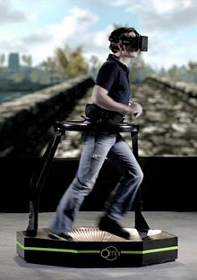Introduction:

Virtuix Omni is a locomotion simulator for [virtual reality](https://en.wikipedia.org/wiki/Virtual_reality) games and other applications currently in development by Virtuix.. It uses a platform to simulate the motion of walking, requiring special shoes that reduce friction. It works in conjunction with the [Oculus Rift](https://en.wikipedia.org/wiki/Oculus_Rift) or any other head mounted display and allows gamers to walk or run within the game they are playing.

In 2013, the Virtuix Omni became one of the ten biggest technology [Kickstarter](https://en.wikipedia.org/wiki/Kickstarter) campaigns, raising $1.1 million in funding. Since then, Virtuix has raised another $8 million from private and institutional investors.

Although originally slated to be released in January 2014, production of the Omni only began in November 2015. If the current launch target of Q4 2016 is met, it will have been delayed by over two-and-a-half-years.

History:

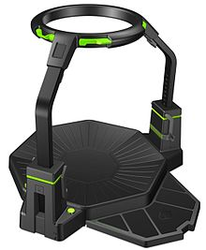Virtuix was founded by Jan Goetgeluk. He quit his investment banking job to develop the project, investing 12 months of his time and a $200,000 personal investment to develop a prototype. The prototype for the Omni used dummy shoes and Kinect software to detect movement instead of the sensor system that became part of the final product. The sensor system was derived from research on an alternative solution: the Rovr from Wizdish. Virtuix presented the prototype of the Omni at the [Electronic Entertainment Expo 2013](https://en.wikipedia.org/wiki/Electronic_Entertainment_Expo_2013) in [Los Angeles, California](https://en.wikipedia.org/wiki/Los_Angeles,_California) where it was reviewed by Engadget and other electronic publications, including [The Verge](https://en.wikipedia.org/wiki/The_Verge).

Virtuix launched a [Kickstarter](https://en.wikipedia.org/wiki/Kickstarter" \o "Kickstarter) campaign in June 2013 to raise money for manufacturing. The campaign was endorsed by [Oculus Rift](https://en.wikipedia.org/wiki/Oculus_Rift) founder [Palmer Luckey](https://en.wikipedia.org/wiki/Palmer_Luckey) and overshot its funding goal of $150,000 within three and a half hours of it being posted. The campaign raised a total of $1.1 million when it closed, making it one of the top 10 biggest technology crowdfunding campaigns at the time.

The Omni presented at [SXSW](https://en.wikipedia.org/wiki/South_by_Southwest) in 2014 where Virtuix founder Jan Goetgeluk also spoke on the topic of virtual reality. The final version of the Virtuix Omni was presented at the 2015 [Consumer Electronics Show](https://en.wikipedia.org/wiki/Consumer_Electronics_Show) in [Las Vegas, Nevada](https://en.wikipedia.org/wiki/Las_Vegas,_Nevada). It was described as "sleek" compared to its previous versions.

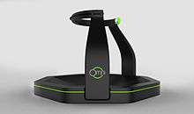Product overview:

The Omni is a locomotion simulator designed to work as a game controller and allow gamers to walk within the game environment in which they are playing. It is used in tandem with Oculus Rift or other virtual reality head mounted displays and is a peripheral for a full virtual reality game setup. The surface is bowl shaped and requires special low friction shoes in order to operate it. It uses inertial sensors to track a person's position, the length of their stride, and how fast they are moving. The information is then sent to a computer which translates the data into the game movements.

UNITY 5

Overview:

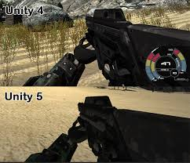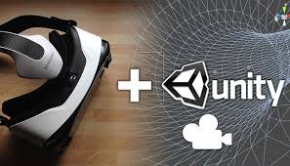With an emphasis on portability, the engine targets the following APIs: [Direct3D](https://en.wikipedia.org/wiki/Microsoft_Direct3D) on Windows and Xbox 360; [OpenGL](https://en.wikipedia.org/wiki/OpenGL) on Mac, Linux, and Windows; [OpenGL ES](https://en.wikipedia.org/wiki/OpenGL_ES) on Android and iOS; and proprietary APIs on [video game consoles](https://en.wikipedia.org/wiki/Video_game_console). Unity allows specification of [texture compression](https://en.wikipedia.org/wiki/Texture_compression) and resolution settings for each platform that the game engine supports,[[6]](https://en.wikipedia.org/wiki/Unity_(game_engine)#cite_note-Unity_Multiplatform-6) and provides support for [bump mapping](https://en.wikipedia.org/wiki/Bump_mapping), [reflection mapping](https://en.wikipedia.org/wiki/Reflection_mapping), [parallax mapping](https://en.wikipedia.org/wiki/Parallax_mapping), [screen space ambient occlusion](https://en.wikipedia.org/wiki/Screen_space_ambient_occlusion) (SSAO), dynamic shadows using [shadow maps](https://en.wikipedia.org/wiki/Shadow_map), [render-to-texture](https://en.wikipedia.org/wiki/Render_to_Texture) and full-screen post-processing effects.[[10]](https://en.wikipedia.org/wiki/Unity_(game_engine)#cite_note-Unity_4_DirectX11-10) Unity's graphics engine's platform diversity can provide a [shader](https://en.wikipedia.org/wiki/Shader" \o "Shader) with multiple variants and a declarative fallback specification, allowing Unity to detect the best variant for the current video hardware and, if none are compatible, to fall back to an alternative shader that may sacrifice features for performance.[[11]](https://en.wikipedia.org/wiki/Unity_(game_engine)#cite_note-Unity_Shaders-11)

Unity is notable for its ability to target games to multiple platforms. Within a project, developers have control over delivery to mobile devices, web browsers, desktops, and consoles.[[6]](https://en.wikipedia.org/wiki/Unity_(game_engine)#cite_note-Unity_Multiplatform-6)[[12]](https://en.wikipedia.org/wiki/Unity_(game_engine)#cite_note-12) Supported platforms include [Android](https://en.wikipedia.org/wiki/Android_(operating_system)), [Apple TV](https://en.wikipedia.org/wiki/Apple_TV),[[13]](https://en.wikipedia.org/wiki/Unity_(game_engine)#cite_note-13) [BlackBerry 10](https://en.wikipedia.org/wiki/BlackBerry_10), [iOS](https://en.wikipedia.org/wiki/IOS), [Linux](https://en.wikipedia.org/wiki/Linux), [Nintendo 3DS line](https://en.wikipedia.org/wiki/Nintendo_3DS_line),[[14]](https://en.wikipedia.org/wiki/Unity_(game_engine)#cite_note-UnityTech-announces-NN3DSsupport-14)[[15]](https://en.wikipedia.org/wiki/Unity_(game_engine)#cite_note-IGNcitesUnityNN3DSsupport-15)[[16]](https://en.wikipedia.org/wiki/Unity_(game_engine)#cite_note-unity-europe-announces-new-3ds-details-16) [macOS](https://en.wikipedia.org/wiki/MacOS" \o "MacOS), [PlayStation 4](https://en.wikipedia.org/wiki/PlayStation_4), [PlayStation Vita](https://en.wikipedia.org/wiki/PlayStation_Vita), Unity Web Player (including Facebook[[17]](https://en.wikipedia.org/wiki/Unity_(game_engine)#cite_note-17)), [Wii](https://en.wikipedia.org/wiki/Wii), [Wii U](https://en.wikipedia.org/wiki/Wii_U), [Windows Phone 8](https://en.wikipedia.org/wiki/Windows_Phone_8), [Windows](https://en.wikipedia.org/wiki/Microsoft_Windows), [Xbox 360](https://en.wikipedia.org/wiki/Xbox_360), and [Xbox One](https://en.wikipedia.org/wiki/Xbox_One). It includes an asset server and [Nvidia's](https://en.wikipedia.org/wiki/Nvidia" \o "Nvidia) [PhysX](https://en.wikipedia.org/wiki/PhysX) physics engine. Unity Web Player is a browser plugin that is supported in Windows and OS X only,[[18]](https://en.wikipedia.org/wiki/Unity_(game_engine)" \l "cite_note-18) which has been deprecated in favor of [WebGL](https://en.wikipedia.org/wiki/WebGL" \o "WebGL).[[3]](https://en.wikipedia.org/wiki/Unity_(game_engine)#cite_note-WPRoadmap-3) Unity is the default [software development kit](https://en.wikipedia.org/wiki/Software_development_kit) (SDK) for Nintendo's [Wii U](https://en.wikipedia.org/wiki/Wii_U) [video game console](https://en.wikipedia.org/wiki/Video_game_console) platform, with a free copy included by Nintendo with each Wii U developer license. Unity Technologies calls this bundling of a third-party SDK an "industry first"

Marketing:

On December 16, 2013, Unity Technologies Japan revealed new screenshots for an official mascot character named Unity-chan (ユニティちゃん *Yuniti-chan***[?](https://en.wikipedia.org/wiki/Help:Installing_Japanese_character_sets" \o "Help:Installing Japanese character sets)**), real name Kohaku Otori (大鳥 こはく *Ōtori Kohaku***[?](https://en.wikipedia.org/wiki/Help:Installing_Japanese_character_sets" \o "Help:Installing Japanese character sets)**) (voiced by [Asuka Kakumoto](https://ja.wikipedia.org/wiki/%E8%A7%92%E5%85%83%E6%98%8E%E6%97%A5%E9%A6%99" \o "ja:角元明日香)), with exhibit of the character in Comic Market 85 event in the Tokyo Big Sight between December 29 to the 31st, where themed goods would be distributed and her voice actress would be present at the event. The character's associated game data were to be released in spring 2014.[[28]](https://en.wikipedia.org/wiki/Unity_(game_engine)#cite_note-28)[[29]](https://en.wikipedia.org/wiki/Unity_(game_engine)#cite_note-29)[[30]](https://en.wikipedia.org/wiki/Unity_(game_engine)#cite_note-30) The character was designed by Unity Technologies Japan designer 'ntny' as an open-source heroine character.[[31]](https://en.wikipedia.org/wiki/Unity_(game_engine)#cite_note-31) The company allows the use of Unity-chan and related characters in secondary projects under certain licenses.[[32]](https://en.wikipedia.org/wiki/Unity_(game_engine)#cite_note-32) For example, Unity-chan appears as a playable character in *[Runbow](https://en.wikipedia.org/wiki/Runbow" \o "Runbow)*.[[33]](https://en.wikipedia.org/wiki/Unity_(game_engine)#cite_note-33) The popularity of the character also led to her appearance in [Vocaloid](https://en.wikipedia.org/wiki/Vocaloid" \o "Vocaloid) adaptions, including her own sound library for [Vocaloid 4](https://en.wikipedia.org/wiki/Vocaloid_4" \o "Vocaloid 4) and a special adaption of Vocaloid designed to work with the Unity Engine 5.0 version called [Unity with Vocaloid](https://en.wikipedia.org/wiki/Unity_with_Vocaloid).

Programming Language

Definition:

A programming language is a notation for writing [programs](https://en.wikipedia.org/wiki/Computer_program), which are specifications of a computation or [algorithm](https://en.wikipedia.org/wiki/Algorithm). Some, but not all, authors restrict the term "programming language" to those languages that can express *all* possible algorithms. Traits often considered important for what constitutes a programming language include:

**Function and target:**

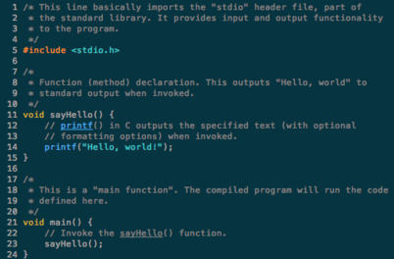A *computer programming language* is a [language](https://en.wikipedia.org/wiki/Formal_language) used to write [computer programs](https://en.wikipedia.org/wiki/Computer_program), which involve a [computer](https://en.wikipedia.org/wiki/Computer) performing some kind of computation or [algorithm](https://en.wikipedia.org/wiki/Algorithm) and possibly control external devices such as [printers](https://en.wikipedia.org/wiki/Printer_(computing)), [disk drives](https://en.wikipedia.org/wiki/Disk_drive), [robots](https://en.wikipedia.org/wiki/Robot), and so on. For example, [PostScript](https://en.wikipedia.org/wiki/PostScript) programs are frequently created by another program to control a computer printer or display. More generally, a programming language may describe computation on some, possibly abstract, machine. It is generally accepted that a complete specification for a programming language includes a description, possibly idealized, of a machine or processor for that language. In most practical contexts, a programming language involves a computer; consequently, programming languages are usually defined and studied this way. Programming languages differ from [natural languages](https://en.wikipedia.org/wiki/Natural_language) in that natural languages are only used for interaction between people, while programming languages also allow humans to communicate instructions to machines.

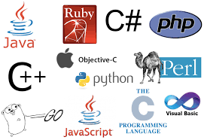**Abstractions:**

Programming languages usually contain [abstractions](https://en.wikipedia.org/wiki/Abstraction_(computer_science)) for defining and manipulating [data structures](https://en.wikipedia.org/wiki/Data_structure) or controlling the [flow of execution](https://en.wikipedia.org/wiki/Control_flow). The practical necessity that a programming language support adequate abstractions is expressed by the [abstraction principle](https://en.wikipedia.org/wiki/Abstraction_principle_(programming)); this principle is sometimes formulated as a recommendation to the programmer to make proper use of such abstractions.

Elements:

* Syntax
* Semantics
* Type System
* Standard Library and run time system

**C++**

**Overview:**

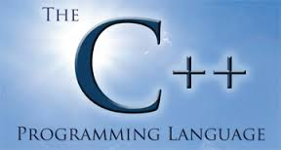**C++** ([pronounced](https://en.wikipedia.org/wiki/English_alphabet#Letter_names) *cee plus plus*) is a [general-purpose programming language](https://en.wikipedia.org/wiki/General-purpose_programming_language).thas [imperative](https://en.wikipedia.org/wiki/Imperative_programming), [object-oriented](https://en.wikipedia.org/wiki/Object-oriented_programming) and [generic](https://en.wikipedia.org/wiki/Generic_programming) programming features, while also providing facilities for [low-level](https://en.wikipedia.org/wiki/Low-level_programming) [memory](https://en.wikipedia.org/wiki/Memory_(computing)) manipulation.It was designed with a bias toward [system programming](https://en.wikipedia.org/wiki/System_programming) and [embedded](https://en.wikipedia.org/wiki/Embedded_software), resource-constrained and [large systems](https://en.wikipedia.org/wiki/Programming_in_the_large), with [performance](https://en.wikipedia.org/wiki/Performance_(software)), efficiency and flexibility of use as its design highlights. C++ has also been found useful in many other contexts, with key strengths being software infrastructure, resource-constrained applications, including [desktop applications](https://en.wikipedia.org/wiki/Application_software),servers (e.g. [e-commerce](https://en.wikipedia.org/wiki/E-commerce), [web search](https://en.wikipedia.org/wiki/Web_search_engine) or [SQL](https://en.wikipedia.org/wiki/SQL) servers), and performance-critical applications (e.g. [telephone switches](https://en.wikipedia.org/wiki/Telephone_switches) or [space probes](https://en.wikipedia.org/wiki/Space_probes)). C++ is a [compiled language](https://en.wikipedia.org/wiki/Compiled_language), with implementations of it available on many platforms and provided by various organizations, including the [Free Software Foundation (FSF's GCC)](https://en.wikipedia.org/wiki/GNU_Compiler_Collection), [LLVM](https://en.wikipedia.org/wiki/Clang), [Microsoft](https://en.wikipedia.org/wiki/Visual_C%2B%2B), [Intel](https://en.wikipedia.org/wiki/Intel_C%2B%2B_Compiler) and [IBM](https://en.wikipedia.org/wiki/IBM_XL_C%2B%2B).

History:

In 1979, [Bjarne Stroustrup](https://en.wikipedia.org/wiki/Bjarne_Stroustrup" \o "Bjarne Stroustrup), a Danish [computer scientist](https://en.wikipedia.org/wiki/Computer_scientist), began work on "C with [Classes](https://en.wikipedia.org/wiki/Class_(computer_programming))", the predecessor to C++. The motivation for creating a new language originated from Stroustrup's experience in programming for his Ph.D. thesis. Stroustrup found that [Simula](https://en.wikipedia.org/wiki/Simula" \o "Simula) had features that were very helpful for large software development, but the language was too slow for practical use, while [BCPL](https://en.wikipedia.org/wiki/BCPL) was fast but too low-level to be suitable for large software development.

 In 1983, "C with Classes" was renamed to "C++" ("++" being the [increment operator](https://en.wikipedia.org/wiki/Increment_operator) in C), adding new features that included [virtual functions](https://en.wikipedia.org/wiki/Virtual_function), function name and [operator overloading](https://en.wikipedia.org/wiki/Operator_overloading), references, constants, type-safe free-store memory allocation (new/delete), improved type checking, and BCPL style single-line comments with two forward slashes (//). Furthermore, it included the development of a standalone compiler for C++, [Cfront](https://en.wikipedia.org/wiki/Cfront" \o "Cfront).

In 1985, the first edition of [*The C++ Programming Language*](https://en.wikipedia.org/wiki/The_C%2B%2B_Programming_Language) was released, which became the definitive reference for the language, as there was not yet an official standard. The first commercial implementation of C++ was released in October of the same year. In 1989, C++ 2.0 was released, followed by the updated second edition of *The C++ Programming Language* in 1991. New features in 2.0 included multiple inheritance, abstract classes, static member functions, [const member functions](https://en.wikipedia.org/wiki/Const_correctness" \o "Const correctness), and protected members. In 1990, *The Annotated C++ Reference Manual* was published. This work became the basis for the future standard. Later feature additions included [templates](https://en.wikipedia.org/wiki/Template_(programming)), [exceptions](https://en.wikipedia.org/wiki/Exception_handling), [namespaces](https://en.wikipedia.org/wiki/Namespaces), new [casts](https://en.wikipedia.org/wiki/Cast_(computer_science)), and a [boolean type](https://en.wikipedia.org/wiki/Boolean_datatype" \o "Boolean datatype) .After the 2.0 update, C++ evolved relatively slowly until, in 2011, the [C++11](https://en.wikipedia.org/wiki/C%2B%2B11) standard was released, adding numerous new features, enlarging the standard library further, and providing more facilities to C++ programmers. After a minor [C++14](https://en.wikipedia.org/wiki/C%2B%2B14) update released in December 2014, various new additions are [planned for 2017](https://en.wikipedia.org/wiki/C%2B%2B#Standardization) and 2020.

**C#**

**Overview:**

**C#**[[note 2]](https://en.wikipedia.org/wiki/C_Sharp_(programming_language)#cite_note-13) (pronounced as *see sharp*) is a [multi-paradigm programming language](https://en.wikipedia.org/wiki/Multi-paradigm_programming_language) encompassing [strong typing](https://en.wikipedia.org/wiki/Strong_typing), [imperative](https://en.wikipedia.org/wiki/Imperative_programming), [declarative](https://en.wikipedia.org/wiki/Declarative_programming), [functional](https://en.wikipedia.org/wiki/Functional_programming), [generic](https://en.wikipedia.org/wiki/Generic_programming), [object-oriented](https://en.wikipedia.org/wiki/Object-oriented_programming) ([class](https://en.wikipedia.org/wiki/Class_(computer_science))-based),and [component-oriented](https://en.wikipedia.org/wiki/Component-based_software_engineering) programming disciplines. It was developed by [Microsoft](https://en.wikipedia.org/wiki/Microsoft) within its [.NET](https://en.wikipedia.org/wiki/.NET_Framework) initiative and later approved as a standard by [Ecma](https://en.wikipedia.org/wiki/Ecma_International" \o "Ecma International) (ECMA-334) and [ISO](https://en.wikipedia.org/wiki/International_Organization_for_Standardization) (ISO/IEC 23270:2006). C# is one of the programming languages designed for the [Common Language Infrastructure](https://en.wikipedia.org/wiki/Common_Language_Infrastructure).

C# is a general-purpose, object-oriented programming language.Its development team is led by [Anders Hejlsberg](https://en.wikipedia.org/wiki/Anders_Hejlsberg). The most recent version is C# 6.0 which was released in 2015.

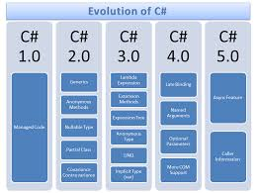Name:

The name "C sharp" was inspired by musical notation where a [sharp](https://en.wikipedia.org/wiki/Sharp_(music)) indicates that the written note should be made a [semitone](https://en.wikipedia.org/wiki/Semitone) higher in [pitch](https://en.wikipedia.org/wiki/Pitch_(music)" \o "Pitch (music)).This is similar to the language name of [C++](https://en.wikipedia.org/wiki/C%2B%2B), where "++" indicates that a variable should be incremented by 1. The sharp symbol also resembles a [ligature](https://en.wikipedia.org/wiki/Typographic_ligature) of four "+" symbols (in a two-by-two grid), further implying that the language is an increment of C++.

Design Goals:

The ECMA standard lists these design goals for C#:

* 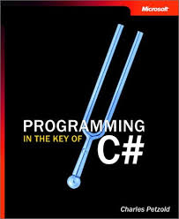The language is intended to be a simple, modern, general-purpose, [object-oriented programming](https://en.wikipedia.org/wiki/Object-oriented_programming) language.
* The language, and implementations thereof, should provide support for software engineering principles such as [strong type](https://en.wikipedia.org/wiki/Strong_type) checking, array [bounds checking](https://en.wikipedia.org/wiki/Bounds_checking), detection of attempts to use [uninitialized variables](https://en.wikipedia.org/wiki/Uninitialized_variable), and automatic [garbage collection](https://en.wikipedia.org/wiki/Garbage_collection_(computer_science)). Software robustness, durability, and programmer productivity are important.
* The language is intended for use in developing [software components](https://en.wikipedia.org/wiki/Software_components) suitable for deployment in distributed environments.
* Although C# applications are intended to be economical with regard to memory and [processing power](https://en.wikipedia.org/wiki/Processing_power) requirements, the language was not intended to compete directly on performance and size with C or assembly language.

Property:

C# provides [properties](https://en.wikipedia.org/wiki/Property_(programming)) as [syntactic sugar](https://en.wikipedia.org/wiki/Syntactic_sugar) for a common pattern in which a pair of methods, [accessor (getter) and mutator (setter)](https://en.wikipedia.org/wiki/Mutator_method" \o "Mutator method) encapsulate operations on a single [attribute](https://en.wikipedia.org/wiki/Attribute_(computing)) of a class. No redundant method signatures for the getter/setter implementations need be written, and the property may be accessed using attribute syntax rather than more verbose method calls.

Microsoft DirectX

Development and History:

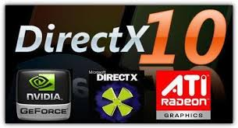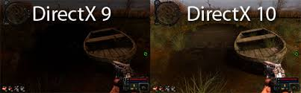In late 1994, Microsoft was ready to release [Windows 95](https://en.wikipedia.org/wiki/Windows_95), its next [operating system](https://en.wikipedia.org/wiki/Operating_system). An important factor in the value consumers would place on it was the programs that would be able to run on it. Three Microsoft employees—Craig Eisler, [Alex St. John](https://en.wikipedia.org/wiki/Alex_St._John), and Eric Engstrom—were concerned because [programmers](https://en.wikipedia.org/wiki/Game_programmer) tended to see Microsoft's previous operating system, [MS-DOS](https://en.wikipedia.org/wiki/MS-DOS), as a better platform for game programming, meaning few games would be developed for Windows 95 and the operating system would not be as much of a success. This was compounded by negative reception surrounding the Windows port of [*The Lion King*](https://en.wikipedia.org/wiki/The_Lion_King_(video_game))

The first version of DirectX was released in September 1995 as the Windows Games SDK. It was the [Win32](https://en.wikipedia.org/wiki/Windows_API) replacement for the DCI and WinG APIs for [Windows 3.1](https://en.wikipedia.org/wiki/Windows_3.1). DirectX allowed all versions of Microsoft Windows, starting with Windows 95, to incorporate high-performance multimedia. Eisler wrote about the frenzy to build DirectX 1 through 5 in his blog.

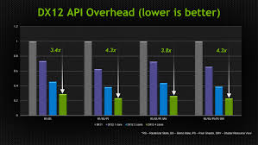DirectX 2.0 became a component of Windows itself with the releases of [Windows 95](https://en.wikipedia.org/wiki/Windows_95) OSR2 and [Windows NT 4.0](https://en.wikipedia.org/wiki/Windows_NT_4.0) in mid-1996. Since Windows 95 was itself still new and few games had been released f or it, Microsoft engaged in heavy promotion of DirectX to developers who were generally distrustful of Microsoft's ability to build a gaming platform in Windows. Alex St. John, the evangelist for DirectX, staged an elaborate event at the 1996 [Computer Game Developers Conference](https://en.wikipedia.org/wiki/Game_Developers_Conference) which game developer Jay Barnson described as a [Roman](https://en.wikipedia.org/wiki/Ancient_Rome) theme, including real [lions](https://en.wikipedia.org/wiki/Lion), togas, and something resembling an indoor carnival. It was at this event that Microsoft first introduced [Direct3D](https://en.wikipedia.org/wiki/Direct3D) and [DirectPlay](https://en.wikipedia.org/wiki/DirectPlay), and demonstrated multiplayer [*MechWarrior 2*](https://en.wikipedia.org/wiki/MechWarrior_2) being played over the Internet.

The DirectX team faced the challenging task of testing each DirectX release against an array of [computer hardware](https://en.wikipedia.org/wiki/Computer_hardware) and [software](https://en.wikipedia.org/wiki/Software). A variety of different graphics cards, audio cards, motherboards, CPUs, input devices, games, and other multimedia applications were tested with each beta and final release. The DirectX team also built and distributed tests that allowed the hardware industry to confirm that new hardware designs and driver releases would be compatible with DirectX.

In a console-specific version, DirectX was used as a basis for Microsoft's [Xbox](https://en.wikipedia.org/wiki/Xbox_(console)), [Xbox 360](https://en.wikipedia.org/wiki/Xbox_360) and [Xbox One](https://en.wikipedia.org/wiki/Xbox_One) [console](https://en.wikipedia.org/wiki/Video_game_console) API. The API was developed jointly between Microsoft and [Nvidia](https://en.wikipedia.org/wiki/Nvidia" \o "Nvidia), which developed the custom graphics hardware used by the original Xbox. The Xbox API was similar to DirectX version 8.1, but is non-updateable like other console technologies. The Xbox was code named DirectXbox, but this was shortened to Xbox for its commercial name. In 2002, Microsoft released DirectX 9 with support for the use of much longer shader programs than before with pixel and vertex shader version 2.0. Microsoft has continued to update the DirectX suite since then, introducing Shader Model 3.0 in DirectX 9.0c, released in August 2004.As of April 2005, [DirectShow](https://en.wikipedia.org/wiki/DirectShow) was removed from Directx.

GPU

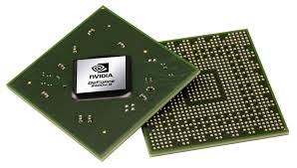Overview:

A **graphics processing unit** (**GPU**), occasionally called **visual processing unit** (**VPU**), is a specialized [electronic circuit](https://en.wikipedia.org/wiki/Electronic_circuit) designed to rapidly manipulate and alter [memory](https://en.wikipedia.org/wiki/Memory_(computing)) to accelerate the creation of [images](https://en.wikipedia.org/wiki/Image) in a [frame buffer](https://en.wikipedia.org/wiki/Frame_buffer) intended for output to a [display device](https://en.wikipedia.org/wiki/Display_device). GPUs are used in [embedded systems](https://en.wikipedia.org/wiki/Embedded_system), [mobile phones](https://en.wikipedia.org/wiki/Mobile_phone), [personal computers](https://en.wikipedia.org/wiki/Personal_computer), [workstations](https://en.wikipedia.org/wiki/Workstation), and [game consoles](https://en.wikipedia.org/wiki/Game_console). Modern GPUs are very efficient at manipulating [computer graphics](https://en.wikipedia.org/wiki/Computer_graphics) and [image processing](https://en.wikipedia.org/wiki/Image_processing), and their highly parallel structure makes them more efficient than general-purpose [CPUs](https://en.wikipedia.org/wiki/Central_processing_unit) for [algorithms](https://en.wikipedia.org/wiki/Algorithm) where the processing of large blocks of data is done in parallel. In a personal computer, a GPU can be present on a [video card](https://en.wikipedia.org/wiki/Video_card), or it can be embedded on the [motherboard](https://en.wikipedia.org/wiki/Motherboard) or—in certain CPUs—on the CPU [die](https://en.wikipedia.org/wiki/Die_(integrated_circuit)).

The term GPU was popularized by [Nvidia](https://en.wikipedia.org/wiki/Nvidia" \o "Nvidia) in 1999, who marketed the [GeForce 256](https://en.wikipedia.org/wiki/GeForce_256) as "the world's first GPU", or Graphics Processing Unit. It was presented as a "single-chip processor with integrated [transform, lighting, triangle setup/clipping](https://en.wikipedia.org/wiki/Transform,_clipping,_and_lighting), and rendering engines".Rival [ATI Technologies](https://en.wikipedia.org/wiki/ATI_Technologies) coined the term "visual processing unit" or VPU with the release of the [Radeon 9700](https://en.wikipedia.org/wiki/R300) in 2002.

History: (2010 to present)

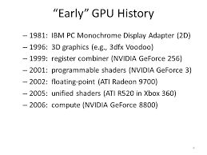In 2010, Nvidia began a partnership with Audi to power their cars' dashboards. These [Tegra](https://en.wikipedia.org/wiki/Tegra" \o "Tegra) GPUs were powering the cars' dashboard, offering increased functionality to cars' navigation and entertainment systems.[[44]](https://en.wikipedia.org/wiki/Graphics_processing_unit#cite_note-44) Advancements in GPU technology in cars has helped push self-driving technology.[[45]](https://en.wikipedia.org/wiki/Graphics_processing_unit#cite_note-45) AMD's [Radeon HD 6000 Series](https://en.wikipedia.org/wiki/Radeon_HD_6000_Series) cards were released in 2010 and in 2011, AMD released their 6000M Series discrete GPUs to be used in mobile devices.[[46]](https://en.wikipedia.org/wiki/Graphics_processing_unit#cite_note-46) The Kepler line of graphics cards by Nvidia came out in 2012 and were used in the 600 series, 700 series, and 800 series of graphics cards by Nvidia. A new feature in this new GPU microarchitecture included gpu boost, a technology adjusts the clock-speed of a video card to increase or decrease it according to its power draw.[[47]](https://en.wikipedia.org/wiki/Graphics_processing_unit#cite_note-47) The [Kepler microarchitecture](https://en.wikipedia.org/wiki/Kepler_(microarchitecture)) was manufactured on the 28 nm process.

[Virtual reality](https://en.wikipedia.org/wiki/Virtual_reality) [headsets](https://en.wikipedia.org/wiki/Virtual_reality_headset) like the [Oculus Rift](https://en.wikipedia.org/wiki/Oculus_Rift) and the [HTC Vive](https://en.wikipedia.org/wiki/HTC_Vive) have very high system requirements. Headset manufacturers have recommended GPUs for good virtual reality experiences. At their release, they had the GTX 970 from Nvidia and the R9 290 from AMD as the recommended GPUs.

### Image result for GPU FunctionComputational function:

Modern GPUs use most of their [transistors](https://en.wikipedia.org/wiki/Transistor) to do calculations related to [3D computer graphics](https://en.wikipedia.org/wiki/3D_computer_graphics). They were initially used to accelerate the memory-intensive work of [texture mapping](https://en.wikipedia.org/wiki/Texture_mapping) and [rendering](https://en.wikipedia.org/wiki/Rendering_(computer_graphics)) polygons, later adding units to accelerate [geometric](https://en.wikipedia.org/wiki/Geometry) calculations such as the [rotation](https://en.wikipedia.org/wiki/Rotation) and [translation](https://en.wikipedia.org/wiki/Translation_(geometry)) of [vertices](https://en.wikipedia.org/wiki/Vertex_(geometry)) into different [coordinate systems](https://en.wikipedia.org/wiki/Coordinate_system). Recent developments in GPUs include support for [programmable shaders](https://en.wikipedia.org/wiki/Programmable_shader) which can manipulate vertices and textures with many of the same operations supported by [CPUs](https://en.wikipedia.org/wiki/Central_processing_unit), [oversampling](https://en.wikipedia.org/wiki/Oversampling) and [interpolation](https://en.wikipedia.org/wiki/Interpolation) techniques to reduce [aliasing](https://en.wikipedia.org/wiki/Aliasing), and very high-precision [color spaces](https://en.wikipedia.org/wiki/Color_space).In addition to the 3D hardware, today's GPUs include basic 2D acceleration.

Virtual Reality

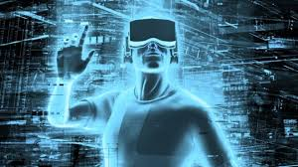Overview:

**Virtual reality** (**VR**) typically refers to [computer](https://en.wikipedia.org/wiki/Computer) technologies that use [software](https://en.wikipedia.org/wiki/Software) to generate the realistic images, sounds and other sensations that replicate a real environment (or create an imaginary setting), and simulate a user's physical presence in this environment.

VR has been defined as "...a realistic and immersive simulation of a [three-dimensional](https://en.wikipedia.org/wiki/Three-dimensional) environment, created using interactive software and [hardware](https://en.wikipedia.org/wiki/Computer_hardware), and experienced or controlled by movement of the body"[[1]](https://en.wikipedia.org/wiki/Virtual_reality#cite_note-1) or as an "immersive, interactive experience generated by a computer".[[2]](https://en.wikipedia.org/wiki/Virtual_reality#cite_note-2)

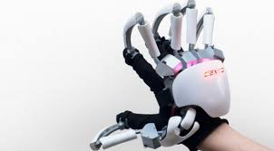A person using virtual reality equipment is typically able to "look around" the artificial world, move about in it and interact with features or items that are depicted on a [screen](https://en.wikipedia.org/wiki/Flatscreen_TV) or in goggles. Most 2016-era virtual realities are displayed either on a [computer monitor](https://en.wikipedia.org/wiki/Computer_monitor), a [projector screen](https://en.wikipedia.org/wiki/Projector_screen), or with a [virtual reality headset](https://en.wikipedia.org/wiki/Virtual_reality_headset) (also called [head-mounted display](https://en.wikipedia.org/wiki/Head-mounted_display) or HMD). HMDs typically take the form of head-mounted goggles with a screen in front of the eyes.

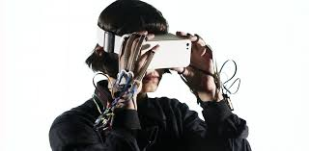Programs may include audio and sounds through speakers or headphones.Advanced [haptic](https://en.wikipedia.org/wiki/Haptic_technology) systems in the 2010s may include tactile information, generally known as [force feedback](https://en.wikipedia.org/wiki/Force_feedback) in medical, [video gaming](https://en.wikipedia.org/wiki/Video_gaming) and military training applications. Some VR systems used in video games can transmit vibrations and other sensations to the user via the [game controller](https://en.wikipedia.org/wiki/Game_controller).

Virtual reality also refers to remote communication environments which provide a virtual presence of users with through [telepresence](https://en.wikipedia.org/wiki/Telepresence" \o "Telepresence) and [telexistence](https://en.wikipedia.org/wiki/Telexistence" \o "Telexistence) or the use of a [virtual artifact](https://en.wikipedia.org/wiki/Virtual_artifact) (VA). The immersive environment can be similar to the real world in order to create a [lifelike experience](https://en.wikipedia.org/wiki/Lifelike_experience) or it can differ significantly from reality where gamers can use fictional powers

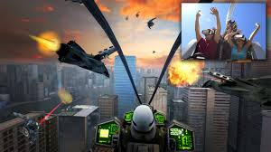Like games:

Accelerometer Sensor

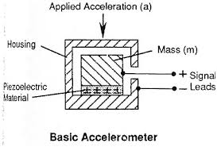Introduction:

One of the most common inertial sensors is the **accelerometer**, a dynamic sensor capable of a vast range of sensing. Accelerometers are available that can measure acceleration in one, two, or three orthogonal axes. They are typically used in one of three modes:

* As an inertial measurement of velocity and position;
* As a sensor of inclination, tilt, or orientation in 2 or 3 dimensions, as referenced from the acceleration of gravity (1 g = 9.8m/s2);
* As a vibration or impact (shock) sensor.

### Image result for accelerometerPrinciples of Operation:

Most accelerometers are Micro-Electro-Mechanical Sensors (MEMS). The basic principle of operation behind the MEMS accelerometer is the displacement of a small proof mass etched into the silicon surface of the integrated circuit and suspended by small beams. Consistent with Newton's second law of motion (**F = ma**), as an acceleration is applied to the device, a force develops which displaces the mass. The support beams act as a spring, and the fluid (usually air) trapped inside the IC acts as a damper, resulting in a second order lumped physical system. This is the source of the limited operational bandwidth and non-uniform frequency response of accelerometers. For more information, see [reference](http://www.sensorwiki.org/doku.php/sensors/accelerometer#external_links_references) to Elwenspoek, 1993.

### Types of Accelerometer:

There are several different principles upon which an analog accelerometer can be built. Two very common types utilize [capacitive sensing](http://www.sensorwiki.org/doku.php/sensors/capacitive) and the [piezoelectric effect](http://www.sensorwiki.org/doku.php/sensors/piezoelectric_ceramic_film) to sense the displacement of the proof mass proportional to the applied acceleration.

### Image result for Accelerometer sensorUses:

The acceleration measurement has a variety of uses. The sensor can be implemented in a system that detects velocity, position, shock, vibration, or the acceleration of gravity to determine orientation (Doscher 2005)A system consisting of two orthogonal sensors is capable of sensing pitch and roll. This is useful in capturing head movements. A third orthogonal sensor can be added to the network to obtain orientation in three dimensional space.

Gyroscope

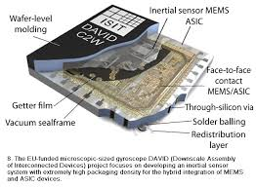Description:

A gyroscope is a wheel mounted in two or three [gimbals](https://en.wikipedia.org/wiki/Gimbal), which are a pivoted supports that allow the rotation of the wheel about a single axis. A set of three gimbals, one mounted on the other with orthogonal pivot axes, may be used to allow a wheel mounted on the innermost gimbal to have an orientation remaining independent of the orientation, in space, of its support. In the case of a gyroscope with two gimbals, the **outer gimbal**, which is the gyroscope frame, is mounted so as to pivot about an axis in its own plane determined by the support.

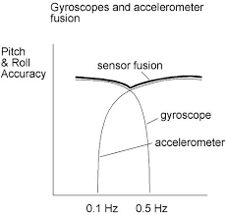This outer gimbal possesses one degree of rotational freedom and its axis possesses none. The **inner gimbal** is mounted in the gyroscope frame (outer gimbal) so as to pivot about an axis in its own plane that is always perpendicular to the pivotal axis of the gyroscope frame (outer gimbal). This inner gimbal has two degrees of rotational freedom.

The axle of the spinning wheel defines the spin axis. The rotor is constrained to spin about an axis, which is always perpendicular to the axis of the inner gimbal. So the rotor possesses three degrees of rotational freedom and its axis possesses two. The wheel responds to a force applied to the input axis by a reaction force to the output axis.The behaviour of a gyroscope can be most easily appreciated by consideration of the front wheel of a bicycle.

If the wheel is leaned away from the vertical so that the top of the wheel moves to the left, the forward rim of the wheel also turns to the left. In other words, rotation on one axis of the turning wheel produces rotation of the third axis.

A **gyroscope flywheel** will roll or resist about the output axis depending upon whether the output gimbals are of a free- or fixed- configuration. Examples of some free-output-gimbal devices would be the attitude reference gyroscopes used to sense or measure the pitch, roll and yaw attitude angles in a spacecraft or aircraft

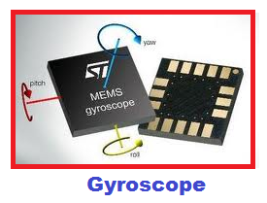The centre of gravity of the rotor can be in a fixed position. The rotor simultaneously spins about one axis and is capable of oscillating about the two other axes, and, thus, except for its inherent resistance due to rotor spin, it is free to turn in any direction about the fixed point. Some gyroscopes have mechanical equivalents substituted for one or more of the elements. For example, the spinning rotor may be suspended in a fluid, instead of being pivotally mounted in gimbals. A [control moment gyroscope](https://en.wikipedia.org/wiki/Control_moment_gyroscope) (CMG) is an example of a fixed-output-gimbal device that is used on spacecraft to hold or maintain a desired attitude angle or pointing direction using the gyroscopic resistance force.

In some special cases, the outer gimbal (or its equivalent) may be omitted so that the rotor has only two degrees of freedom. In other cases, the centre of gravity of the rotor may be offset from the axis of oscillation, and, thus, the centre of gravity of the rotor and the centre of suspension of the rotor may not coincide.

Magnetometer

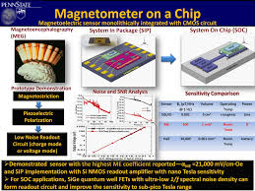Overview:

A **magnetometer** is an instrument that measures magnetism—either [magnetization](https://en.wikipedia.org/wiki/Magnetization) of magnetic material like a [ferromagnet](https://en.wikipedia.org/wiki/Ferromagnet" \o "Ferromagnet), or the strength and, in some cases, direction of the [magnetic field](https://en.wikipedia.org/wiki/Magnetic_field) at a point in space.The first magnetometer was invented by [Carl Friedrich Gauss](https://en.wikipedia.org/wiki/Carl_Friedrich_Gauss) in 1833 and notable developments in the 19th century included the [Hall Effect](https://en.wikipedia.org/wiki/Hall_Effect), which is still widely used.Magnetometers are widely used for measuring the [Earth's magnetic field](https://en.wikipedia.org/wiki/Earth%27s_magnetic_field) and in [geophysical surveys](https://en.wikipedia.org/wiki/Geophysical_survey) to detect [magnetic anomalies](https://en.wikipedia.org/wiki/Magnetic_anomalies) of various types. They are also used in the military to detect submarines. Consequently, some countries, such as the United States, Canada and Australia, classify the more sensitive magnetometers as military technology, and control their distribution.Magnetometers can be used as [metal detectors](https://en.wikipedia.org/wiki/Metal_detectors): they can detect only magnetic ([ferrous](https://en.wikipedia.org/wiki/Ferrous)) metals, but can detect such metals at a much larger depth than conventional metal detectors; they are capable of detecting large objects, such as cars, at tens of metres, while a metal detector's range is rarely more than 2 metres.

Performance and Capabilities:

The performance and capabilities of magnetometers are described through their technical specifications.

* 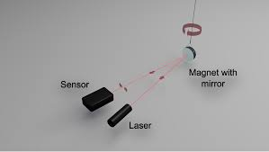Sample rate is the number of readings given per second. The inverse is the cycle time in seconds per reading. Sample rate is important in mobile magnetometers; the sample rate and the vehicle speed determine the distance between measurements.
* Bandwidth or bandpass characterizes how well a magnetometer tracks rapid changes in magnetic field. For magnetometers with no onboard [signal processing](https://en.wikipedia.org/wiki/Signal_processing), bandwidth is determined by the [Nyquist limit](https://en.wikipedia.org/wiki/Nyquist_limit) set by sample rate. Modern magnetometers may perform smoothing or averaging over sequential samples. achieving a lower noise in exchange for lower bandwidth.
* Resolution is the smallest change in magnetic field the magnetometer can resolve. A *magnetometer should have a resolution a good deal smaller than the smallest change one* wishes to observe, to avoid [quantization errors](https://en.wikipedia.org/wiki/Quantization_error).
* Absolute error is the difference between the averaged readings of a magnetometer in a constant magnetic field and true magnetic field.

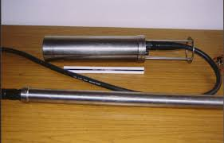Applications:

The caesium and potassium magnetometers are typically used where a higher performance magnetometer than the proton magnetometer is needed. In archaeology and geophysics, where the sensor sweeps through an area and many accurate magnetic field measurements are often needed, caesium and potassium magnetometers have advantages over the proton magnetometer.

**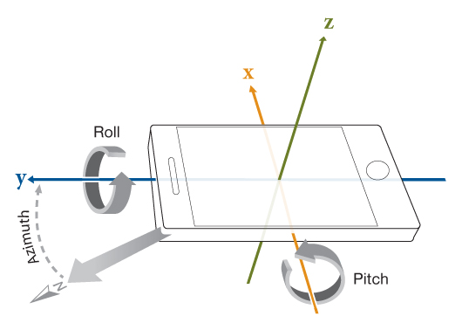Orientation Sensor**

**Orientation sensor**  refers to a less accurate accelerometor sensor can detect only when major change occurs As the Orientation sensor & Gravity sensors are less accurate,They cost low. So, they are used in low cost android phone. **Auto-rotation** is a software in Android which gets the information from Accelerometer(or Orientation sensor/G-sensor) and changes the your screen orientation.

In phones, Accelerometer can be used for screen rotation,gaming purpose & also to measures the force. But Orientation sensor & Gravity sensors can only used for screen rotation.

**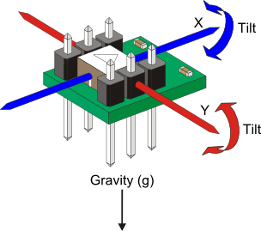Accelerometer**

An **accelerometer** is a device that measures [proper acceleration](https://en.wikipedia.org/wiki/Proper_acceleration); proper acceleration is not the same as coordinate acceleration . For example, an accelerometer at rest on the surface of the Earth will measure an acceleration due to Earth's gravity, straight upwards (by definition) of g ≈ 9.81 m/s2.

**Gyroscope**

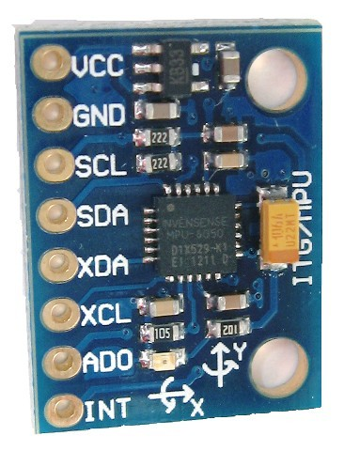A **gyroscope** (from [Ancient Greek](https://en.wikipedia.org/wiki/Ancient_Greek) γῦρος *gûros*, "circle" and σκοπέω *skopéō*, "to look") is a spinning wheel or disc in which the axis of rotation is free to assume any orientation by itself.

**MPU-6050**

The MPU-6050™ parts are the world’s first MotionTracking devices designed for the low power, low cost, and high-performance requirements of smartphones, tablets and wearable sensors.

**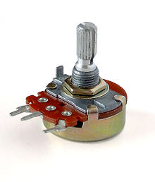Potentiometer**

A **potentiometer**, informally a **pot**, is a three-[terminal](https://en.wikipedia.org/wiki/Terminal_(electronics)) [resistor](https://en.wikipedia.org/wiki/Resistor) with a sliding or rotating contact that forms an adjustable [voltage divider](https://en.wikipedia.org/wiki/Voltage_divider).[[1]](https://en.wikipedia.org/wiki/Potentiometer#cite_note-1) If only two terminals are used, one end and the wiper, it acts as a ***variable resistor*** or ***rheostat***.

The measuring instrument called a [potentiometer](https://en.wikipedia.org/wiki/Potentiometer_(measuring_instrument)) is essentially a [voltage divider](https://en.wikipedia.org/wiki/Voltage_divider) used for measuring [electric potential](https://en.wikipedia.org/wiki/Electric_potential) (voltage); the component is an implementation of the same principle, hence its name.

Potentiometers are commonly used to control electrical devices such as volume controls on audio equipment. Potentiometers operated by a mechanism can be used as position [transducers](https://en.wikipedia.org/wiki/Transducer), for example, in a [joystick](https://en.wikipedia.org/wiki/Joystick). Potentiometers are rarely used to directly control significant power (more than a [watt](https://en.wikipedia.org/wiki/Watt)), since the power dissipated in the potentiometer would be comparable to the power in the controlled load.

Potentiometers consist of a [resistive element](https://en.wikipedia.org/wiki/Electrical_resistivity_and_conductivity), a sliding contact (wiper) that moves along the element, making good electrical contact with one part of it, electrical terminals at each end of the element, a mechanism that moves the wiper from one end to the other, and a housing containing the element and wiper.

**Prototype Board**

**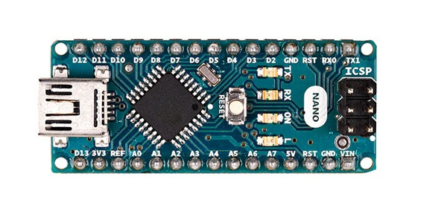**A **prototype** is an early sample, model, or release of a product built to test a concept or process or to act as a thing to be replicated or learned from.[[1]](https://en.wikipedia.org/wiki/Prototype#cite_note-:0-1) It is a term used in a variety of contexts, including [semantics](https://en.wikipedia.org/wiki/Semantics), [design](https://en.wikipedia.org/wiki/Design), [electronics](https://en.wikipedia.org/wiki/Electronics), and [software programming](https://en.wikipedia.org/wiki/Software_prototyping). A prototype is generally used to evaluate a new design to enhance precision by system analysts and users. Prototyping serves to provide specifications for a real, working system rather than a theoretical one.[[2]](https://en.wikipedia.org/wiki/Prototype#cite_note-2) In some design workflow models, creating a prototype (a process sometimes called **materialization**) is the step between the [formalization](https://en.wikipedia.org/wiki/Formal_specification) and the [evaluation](https://en.wikipedia.org/wiki/Evaluation) of an idea.

* **Material** - The materials that will be used in a final product may be expensive or difficult to fabricate, so prototypes may be made from different materials than the final product. In some cases, the final production materials may still be undergoing development themselves and not yet available for use in a prototype. **Process** - Mass-production processes are often unsuitable for making a small number of parts, so prototypes may be made using different fabrication processes than the final product. For example, a final product that will be made by plastic injection molding will require expensive custom tooling, so a prototype for this product may be fabricated by machining or stereolithography instead. Differences in fabrication process may lead to differences in the appearance of the prototype as compared to the final product.
* **Verification -** The final product may be subject to a number of quality assurance tests to verify conformance with drawings or specifications. These tests may involve custom inspection fixtures, statistical sampling methods, and other techniques appropriate for ongoing production of a large quantity of the final product. Prototypes are generally made with much closer individual inspection and the assumption that some adjustment or rework will be part of the fabrication process. Prototypes may also be exempted from some requirements that will apply to the final product.

**Servo**

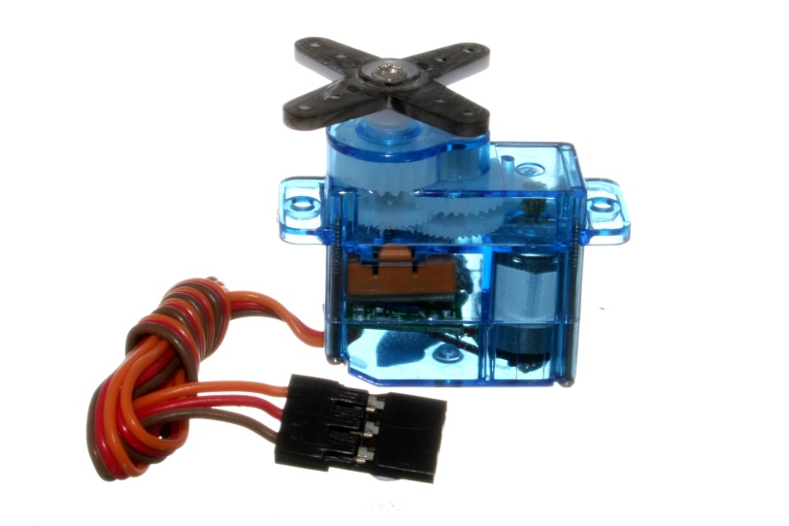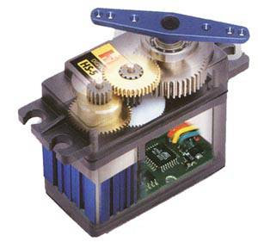A servomechanism, sometimes shortened to **servo**, is an automatic device that uses error-sensing negative feedback to correct the performance of a mechanism and is defined by its function. It usually includes a built-in encodeA **servomotor** is a rotary actuator that allows for precise control of angular position. It consists of a **motor** coupled to a sensor for position feedback. It also requires a**servo** drive to complete the system. The drive uses the feedback sensor to precisely control the rotary position of the **motor**.A vacuum **servo** is a component used on motor vehicles in their **braking** system, to provide assistance to the driver by decreasing the **braking** effort. In the US it is commonly called a **brake** booster.Many industrial **servos** serve as motion control elements. A semiconductor wafer inspection **system** that must position a wafer very precisely is a **servo**. The plant is the linear motor and stage mechanical parts. The linear encoder or laser interferometer is the feedback. The motion controller is the controller.

**NVIDIA:**

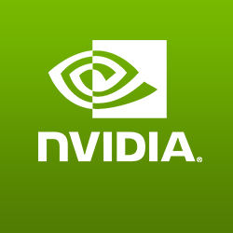

**Nvidia Corporation** most commonly referred to as **Nvidia**, is an American technology company based in Santa Clara, California. Nvidia designs graphics processing units (GPUs) for the gaming market, as well as system on a chip units (SOCs)

for the mobile computing and automotive market. Nvidia's primary GPU product line, labeled "GeForce", is in direct competition with Advanced Micro Devices' (AMD) "Radeon" products. Nvidia expanded its presence in the gaming industry with its handheld SHIELD Portable, SHIELD Tablet,

and SHIELD Android TV

**GeForce:**

is a brand of graphics processing units (GPUs)designed by Nvidia. As of 2016, there have been thirteen iterations of the design. The first GeForce products were discrete GPUs designed for add-on graphics boards, intended for the high-margin PC gaming market, and later diversification of the product line covered all tiers of the PC graphics market, ranging from cost-sensitive GPUs integrated on motherboards, to mainstream add -in retail boards. Most recently, GeForce technology has been introduced into Nvidia's line of embedded application processors, designed for electr -onic handhelds and mobile handse. GTX series 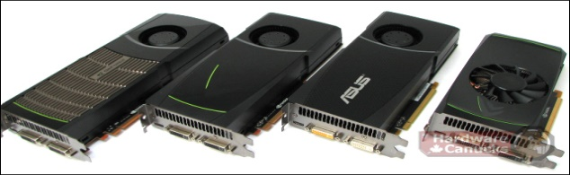.

**TITAN-series:**

TITAN-series graphics cards are the embodiment of perfection, utilizing each generation’s ultimate GPU, the fastest VRAM available, the best components, and the most desirable shrouds. Since 2013 TITAN-series graphics cards have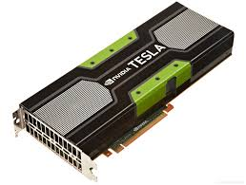 broken records, turned heads, and delivered supercomputer performance andcapabilities to gamers, engineers, medical professionals, and scientists around the world. Today, we unleash NVIDIA TITAN X, the ultimate TITAN, powered by Pascal, the world’s fastest and most advanced architecture.NVIDIA TITAN X has 11 TFLOPS of power, 3584 CUDA Cores, 12GB of 10Gbps GDDR5X VRAM, a 384-bit Memory Interface, 480 GB/sec of Memory Bandwidth, boosts to 1.5GHz out of the box, utilizes superior heat dissipation vapor chamber cooling technology, and features a stunning design. It is, without question, the world’s ultimate graphics card.

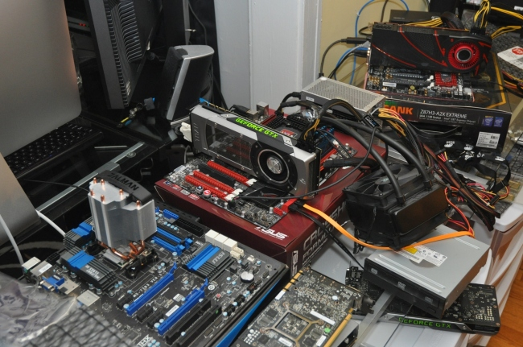

The Titan 1070 is a bit toned down compared to the 1080... 8 Gig of GDDR5 instead of 8 Gig of GDDR5X... 1920 CUDA cores instead of 2560... Boost clock of 1683 MHz instead of 1733 MHz... Memory speed of 8.0 Gbps instead of 10 Gbps... Bandwidth of 256 GB/sec instead of 320 GB/sec...

**nvidia Laptop GPU series:**

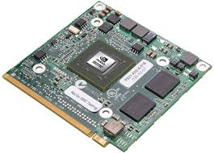 Laptops have historically lagged well behind the performance curve of desktops. But this launch, coming so soon after the desktops launches, is breaking with tradition. Performance of the new GPUs is pretty astounding, the company said, with up to a 76-percent performance improvement over a comparable laptop with a GeForce GTX 980m.The new GeForce GTX 1080, GeForce GTX 1070, and GeForce GTX 1060 are built on the company’s new Pascal architecture and offer significant performance increases over the previous 9-series GPUs.The top-end GeForce GTX 1080 will get 8GB of GDDR5x RAM, a whopping 2,560 CUDA cores, and a boost clock speed of 1,733MHz.b\ The GTX 1070 gets 8GB of RAM, too, but in the more vanilla GDDR5 flavor, with 2,048 cores and a boost clock of 1,645MHz. The GeForce GTX 1060 gets 1,280 CUDA cores, 6GB of GDDR5, and a boost clock speed of 1,670MHz. SLI is supported on the GeForce GTX 1080 and GTX 1070.

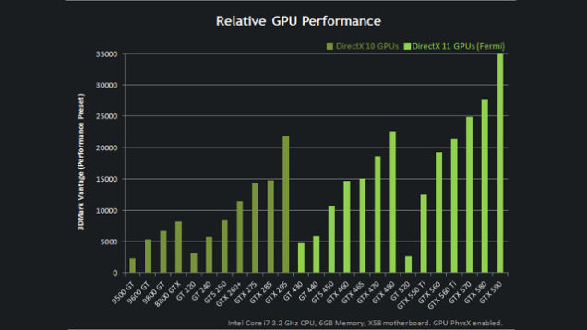The performance of the three GPUs, officials said, should be within 10 percent of a desktop GPU's, whether a little slower or even a little faster. Nvidia attributed the variability to the power and thermal constraints of laptops, depending on the device's physical design. That's not a reflection on the 16nm chip's efficiency, though: Nvidia said the new chips will offer up to 30 percent more battery life compared to an otherwise identical 9-series GPU.

**CUDA technology:** CUDA is a parallel computing platform and application programming interface (API) model created by Nvidia.[1] It allows software developers and software engineers to use a CUDA-enabled graphics processing unit (GPU) for general purpose processing – an approach termed GPGPU (General-Purpose computing on Graphics Processing Units). The CUDA platform is a software layer that gives direct access to the GPU's virtual instruction set and parallel computational elements, for the execution of compute kernels**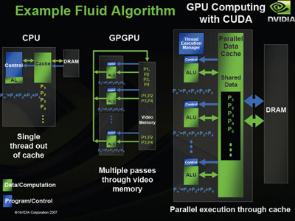**.

**Working Platform:**

The CUDA platform is designed to work with programming languages such as C, C++, and Fortran. This accessibility makes it easier for specialists in parallel programming to use GPU resources, in contrast to prior APIs like Direct3D and OpenGL, which required advanced skills in graphics programming. Also, CUDA supports programming frameworks such as OpenACC and OpenCL. When it was first introduced by Nvidia, the name CUDA was an acronym for Compute Unified Device Architecture, but Nvidia subsequently dropped the use of the acronym.

The CUDA platform is accessible to software developers through CUDA-accelerated libraries, compiler directives such as OpenACC, and extensions to industry-standard programming languages including C, C++ and Fortran. C/C++ programmers use 'CUDA C/C++', compiled with nvcc, Nvidia's LLVM-based C/C++ compiler. Fortran programmers can use 'CUDA Fortran', compiled with the PGI CUDA Fortran compiler from The Portland Group

In addition to libraries, compiler directives, CUDA C/C++ and CUDA Fortran, the CUDA platform supports other computational interfaces.

**SLI technology:**

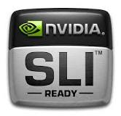

**Scalable Link Interface** (**SLI**) is a brand name for a

multi-GPU **technology** developed by **NVIDIA** for linking

two or more video cards together to produce a single

output **SLI** is an algorithm of parallel processing for com-

puter graphics,meant to increase the processing power

available for graphics.

**IMPLIMENTATION:**

SLI allows two, three, or four graphics processing units (GPUs) to share the workload when rendering real-time 3D computer graphics. Ideally, identical GPUs are installed on the motherboard that contains enough PCI-Express slots, set up in a master-slave configuration. All graphics cards are given an equal workload to render, but the final output of each card is sent to the master card via a connector called the SLI Bridge. An example, in a two graphics card setup, the master works on the top half of the scene, the slave the bottom half. Once the slave is done, it sends its render to the master to combine into one image before sending it to the monitor.

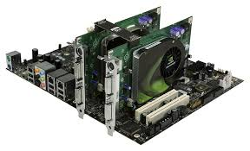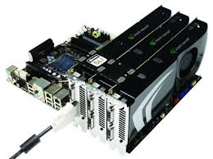The SLI bridge is used to reduce bandwidth constraints and send data between both graphics cards directly. It is possible to run SLI without using the bridge connector on a pair of low-end to mid-range graphics cards (e.g. 7100GS or 6600GT) with NVIDIA's Forceware drivers 80.XX or later. Since these graphics cards do not use as much bandwidth, data can be relayed through just the chipsets on the motherboard. However, if there are two high-end graphics cards installed and the SLI bridge is omitted, the performance will suffer severely as the chipset does not have enough bandwidth.

**PhysX:**

PhysX is a proprietary realtime physics engine middleware SDK. PhysX was authored at NovodeX, an ETH Zurich spin-off. In 2004 NovodeX was acquired by Ageia, and in February 2008 Ageia was acquired by Nvidia.

The term PhysX can also refer to the PPU expansion card designed by Ageia to accelerate PhysX-enabled video games.

Video games supporting hardware acceleration by PhysX can be accelerated by either a PhysX PPU or a CUDA-enabled GeForce GPU (if it has at least 32 cores and a minimum of 256MB dedicated graphics memory[2]), thus offloading physics calculations from the CPU, allowing it to perform other tasks instead.

Middleware physics engines free game developers from writing their own code which implements classical mechanics (Newtonian physics) to do e.g. soft body dynamics. PhysX is one of the handful of physics engines used in the large majority of today's games.

The PhysX engine and SDK are available for Microsoft Windows, macOS, Linux, PlayStation 2, PlayStation 3, PlayStation 4, Xbox 360, Xbox One and the Wii. The PhysX SDK is provided to developers for free for both commercial and non-commercial use on Windows. For Linux, macOS and Android platforms the PhysX SDK is free for educational and non-commercial use.At GDC 2015, Nvidia made PhysX' source code available on GitHub, but requiring registration on the developer.nvidia.com.

The first game to use PhysX was Bet On Soldier: Blood Sport. Nvidia PhysX is part of Nvidia GameWorks.

PhysX is a multi-threaded physics simulation SDK available for Microsoft Windows, macOS, Linux, PlayStation 3, Xbox 360 and Wii. It supports rigid body dynamics, soft body dynamics, ragdolls and character controllers, vehicle dynamics, particles, volumetric fluid simulation and cloth simulation including tearing and pressurized cloth.

**G-Sync Technology:**

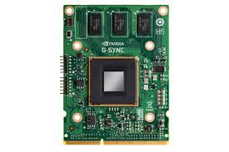G-Sync is a proprietary adaptive sync technology developed by Nvidia aimed primarily to eliminate screen tearing and the need for software deterrents such as Vsync. G-Sync eliminates screen tearing by forcing

a video display to adapt to the framerate of the outputting device rather than the other way around, which could traditionally be refreshed halfway through the process of a frame being output by the device, resulting in two or more frames being shown at once. In order for a device to use G-Sync, it must contain a proprietary G-Sync module sold by Nvidia.

G-Sync faces some criticism due to its proprietary nature, it still being pushed when free alternatives such as the VESA standard Adaptive-Sync, a specific brought from eDP, are now optional features of DisplayPort version 1.2a. While AMD's FreeSync relies on the above-mentioned optional component of DisplayPort 1.2a, G-Sync requires an Nvidia-made module in place of the usual scaler in the display in order for it to function properly with select Nvidia GeForce graphics cards.

However, not all features offered by G-Sync can be achieved by relying on the VESA display standard.

NVIDIA built a special collision avoidance feature to avoid the eventuality of a new frame being ready while a duplicate is painting on the screen (something that could generate lag and/or stutter) in which case they anticipate the refresh and wait for the next frame to be completed.Overdriving pixels also becomes tricky in a non-fixed refresh.

**3D Vision technology:**

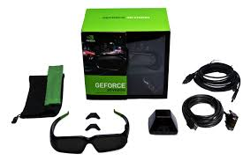3D Vision (previously GeForce 3D Vision) is a stereoscopic gaming kit from Nvidia which consists of LC shutter glasses and driver software which enables stereoscopic vision for any Direct3D game, with various degrees of compatibility. There have been many examples of shutter glasses over the past decade, but the NVIDIA 3D Vision gaming kit introduced in 2008 made this technology available for mainstream consumers and PC gamers.

The kit is specially designed for 120 Hz LCD monitors but is compatible with CRT monitors (some of which may work at 1024×768×120 Hz and even higher refresh rates), DLP-projectors, and others. It requires a compatible graphics card from Nvidia (GeForce 200 series or later)

**Shutter Glasses:**The glasses use wireless IR protocol and can be charged from a USB cable, allowing around 60 hours of continuous use.

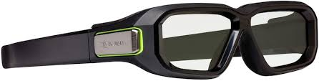The wireless emitter connects to the USB port and interfaces with the underlying driver software. It also contains a VESA Stereo port for connecting supported DLP TV sets, although standalone operation without a PC with installed Nvidia 3D Vision driver is not allowed.NVIDIA includes one pair of shutter glasses in their 3D Vision kit, SKU 942-10701-0003. Each lens operates at 60 Hz, and alternate to create a 120 Hz 3-dimensional experience.

**4k technology:**

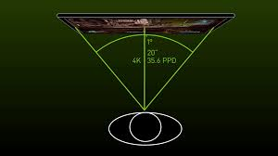4K revolutionizes the way you view your screen by adding four times as many pixels as commonly used 1920x1080 screens, opening your eyes to rich, superbly-detailed worlds. If you have a high-end GeForce GTX PC, you’re ready for the revolution. Just plug and play and you’ll immediately receive a flawless, jaw-dropping experience.

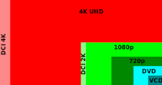

**4K** UHD is a **resolution** of 3840 pixels × 2160

lines (8.3 megapixels, aspect ratio 16:9) and is

one of the two resolutions of ultra high definition

television targeted towards consumer television,

the other being 8K UHD which is 7680 pixels ×

4320 lines (33.2 megapixels)

4K UHD is a resolution of 3840 pixels × 2160 lines (8.3 megapixels, aspect ratio 16:9) and is one of the two resolutions of ultra high definition television targeted towards consumer television, the other being 8K UHD which is 7680 pixels × 4320 lines (33.2 megapixels). UHD has twice the horizontal and vertical resolution of the 1080p HDTV format, with four times as many pixels overall.

Televisions capable of displaying UHD resolutions are seen by consumer electronics companies as the next trigger for an upgrade cycle due to a lack of consumer interest in 3D television.

Besides resolution, the UHD standard and related technologies (e.g. HDMI 2.0) include other higher specifications such as a wider Rec. 2020 color palette.

**ANSEL technology:**

Capture 360° panoramic screenshots in mono or stereo. View these images in Google Cardboard, on your PC, or in a VR headset. For Android and Cardboard users, we've released the NVIDIA VR Viewer, which is bundled with**Ansel** 360° screenshots that you can view today.

Game photography is undeniably a new art form - screenshots can be posed and framed, and those with a great eye will select the best scenes and most beautiful vistas, just as a real world photographer would. The very best screenshots from famous game photographers like Duncan Harris, James Pollock, Leonardo Sang and Joshua Taylor are shown in exhibitions, printed and framed, and admired by millions of gamers online.

Many of us would love to take similar screenshots, and try as we might we simply can't work around the limitations of traditional game capture - views and camera angles can't be changed, enemies continue to attack, and you can only capture a generic shot with the HUD visible.

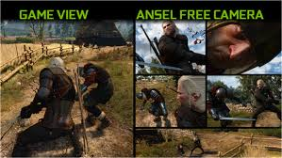Professional game photographers are able to overcome these limitations with exclusive access to developers' internal game builds, custom tools built specially for their work.

.

**DSR technology:**

**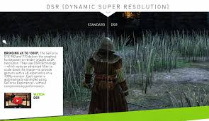**Our new Maxwell architecture introduces a raft of innovative, exciting technologies that make your games better in dramatic ways. Of these new features, Dynamic Super Resolution (DSR) will have largest impact, enhancing any game that supports resolutions above 1920x1080. What does DSR do? Simply put, it renders a game at a higher, more detailed resolution and intelligently shrinks the result back down to the resolution of your monitor, giving you 4K, 3840x2160-quality graphics on any screen.

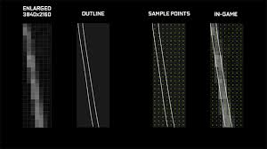Enthusiasts with compatible monitors and technical know-how refer to this process as Downsampling or Super Sampling. DSR drastically improves upon this process by applying a high-quality filter specifically designed for the task. DSR also makes the process simpler with on/off integration built directly into GeForce Experience.

**TXAA technology:**

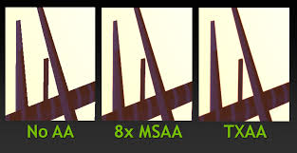TXAA is a new film–style anti–aliasing technique designed specifically to reduce temporal aliasing (crawling and flickering seen in motion when playing games). This technology is a mix of a temporal filter, hardware anti–aliasing, and custom CG film–style anti–aliasing resolves. To filter any given pixel on the screen, TXAA uses a contribution of samples, both inside and outside of the pixel, in conjunction with samples from prior frames, to offer the highest quality filtering possible. TXAA has improved spatial filtering over standard 2xMSAA and 4xMSAA. For example, on fences or foliage and in motion, TXAA starts to approach and sometimes exceeds the quality of other high–end professional anti–aliasing algorithms.

TXAA combines the raw power of MSAA with sophisticated resolve filters similar to those employed in CG films to produce a smoother image far in advance of any comparable technique. Depending on the type of shading implemented in a given game, the performance impact of TXAA can be slightly different. In contrast to methods like FXAA that attempt to maximize performance at the expense of quality, TXAA attempts to maximize quality at the expense of performance. TXAA is a superior option for those looking for the highest–quality anti–aliasing with the most efficient performance possible to make games such as Assassin's Creed IV Black Flag and Batman Arkham Origins look their absolute best.

# Multi-Display Eyefinity Technology

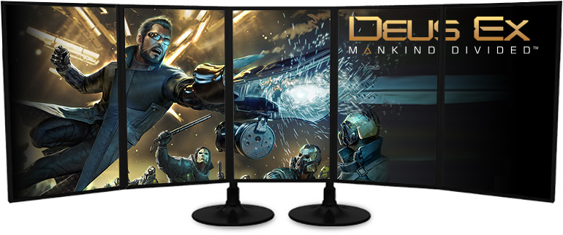

*We are taking you beyond the boundaries of traditional PC displays. AMD Eyefinity technology expands the traditional limits of desktop computing by multiplying your screen area. With multiple monitors, games become more immersive, workstations become more useful and you become more productive.*

**How does AMD Eyefinity technology work?** *On the hardware level, each graphics chip we manufacture is equipped with the ability to support a certain maximum number of displays. The graphics chip is then connected to display outputs (like DVI or DisplayPort), which allow you to physically connect displays. The number and type of display outputs will vary based upon the product and its display output configuration.*

*On the software side, the AMD Catalyst™ driver suite is the one-stop shop for configuring the way your connected displays actually behave. From configuring the orientation to combining their resolutions (more on that later), AMD Catalyst™ makes it easy to get multiple displays up and running*

**What are display outputs?**

*Display outputs are the ports on the back of your graphics card, which can accept a connection with a monitor.*

# AMD Radeon™ R7 Series Graphics Cards Designed for online Gaming

*​​AMD Radeon™ R7 300 Series graphics give you high performance and visual realism while playing your favorite online games including features that take your skills to the next level. Find out why you need them in your arsenal:*

*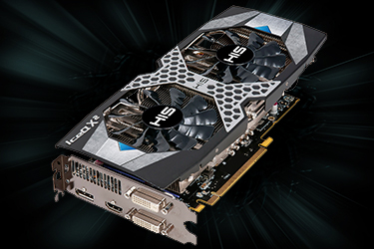​​*

* ​*Get greater than 60 fps gaming performance at 1080p or 1440p, ultra-settings, in popular online games with visual realism that doesn’t sacrifice performance.20, 21*
* *Game at 1080p, or at quality that rivals 1440p with your 1080p display, all thanks to AMD’s Virtual Super Resolution (VSR).4*
* *Play with no tearing or stuttering with*[*AMD FreeSync™ technology*](http://www.amd.com/en-us/innovations/software-technologies/technologies-gaming/freesync)*.5*

**​

*Online gaming supremacy for the gamers who want high-performance with visual realism in the games of today and tomorrow. The power to do it all.*

**AMD STREAM Technology**

​*AMD STREAM technology powers the ecosystem that enables AMD FirePro™ graphics cards to be used for compute-intensive workflows leveraging the massively parallel processing power of AMD GPUs and accelerate many applications beyond just graphics.​*

**

*AMD STREAM technology includes hardware and software optimizations designed for high-performance compute workflows and*[*compute-intensive applications using OpenCL™*](http://www.amd.com/en-us/solutions/professional/hpc/opencl)*, the open and cross-platform programming standard used for general-purpose computations. These features include Error Correcting Code (ECC) memory support, fast floating-point operations and direct memory access that enables low-latency data exchanges between multiple GPUs. When combined with GPU-optimized libraries and third-party middleware, AMD STREAM technology unlocks the computational performance of the AMD FirePro graphics cards.*

* ECC memory
* Fast single- and double-precision floating-point performance
* Bi-directional PCIe® data transfers
* Peer-to-peer multi-GPU support
* GPU-optimized OpenCL™ libraries

**AMD Quick Stream Technology**

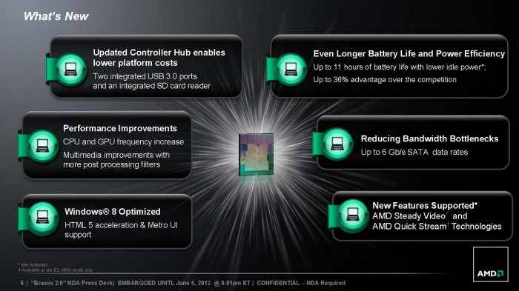**AMD Quick Stream Technology**is an Internet stream optimization software powered by AppEx Networks’ IPEQ (IP End to end Quality Of Service) technology that prioritizes and shapes the Internet data streams flowing in and out the PC, allowing the high‐priority streams and apps to dynamically enjoy the better network resources when competing the limited bandwidth with other less important ones. At the sametime it boosts the overall Internet performance by shaping both the inbound and outbound traffic to eliminate or reduce the chances of traffic congestions. AMD Quick Stream Technology offers the end users smoother and enhanced Internet experiences.

# Surround Computing

*AMD’s innovative technologies enable smarter, intuitive surround computing, whether it’s audio, video, multi-platform, immersive interaction, or managing data from the cloud.*

### Building blocks for surround computing

*AMD’s APUs, CPU and graphics cores, fixed function cores and DSPs, along with our intense graphics processing capabilities and innovative software, are the tools you need in today’s era of surround computing.  Our goal is to offer ambidextrous solutions in both x86 and ARM, for performance and power efficiency in established and up-and-coming workloads. AMD provides supercomputing solutions at commercial cost and power to enable the surround computing revolution.AMD’s immersive 3D musical experience, directed by full 360-degree gesture control off a single AMD chip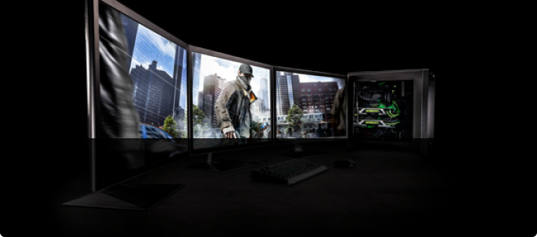*

**Surround**

*With the power of GeForce GPUs, gamers are able to combine up to five displays to create the most immersive gaming environment possible. Here, you can leverage the latest NVIDIA display*

**AMD Crossfire™ Technology, a Multi-GPU Performance Gaming Platform**

***AMD CrossFire****(also known as****CrossFireX****) is a brand name for the multi-GPU technology by****Advanced Micro Devices****, originally developed by ATI Technologies. The technology allows up to four GPUs to be used in a single computer to improve graphics performance.*

How do I turn off CrossFire?

*To****disable Crossfire****right-click your desktop and select "Catalyst Control Center". On the upper-left click "Graphics", then "CrossfireX". In the main area of the window, uncheck the "Enable****Crossfire****" option. Click "OK" to accept the changes and close the Control Center.*

What is a two way CrossFire?

*Dear Dual, Using****two****(or more) video cards in tandem—known as "SLI" for NVIDIA cards and "****Crossfire****" for AMD cards—can get you better performance, sometimes even for less money than you'd spend on a comparable single card solution*

*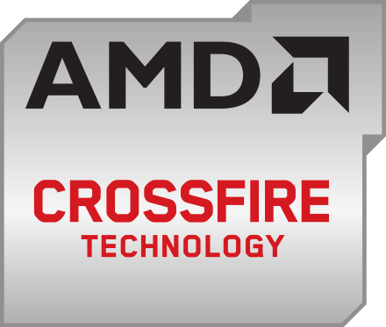*

**AMD CrossFire** (also known as **CrossFireX**) is a brand name for the multi-[GPU](https://en.m.wikipedia.org/wiki/Graphics_processing_unit) technology by [Advanced Micro Devices](https://en.m.wikipedia.org/wiki/Advanced_Micro_Devices), originally developed by [ATI Technologies](https://en.m.wikipedia.org/wiki/ATI_Technologies).[[1]](https://en.m.wikipedia.org/wiki/AMD_CrossFireX#cite_note-1) The technology allows up to four [GPUs](https://en.m.wikipedia.org/wiki/GPU) to be used in a single computer to improve graphics performance.[[2]](https://en.m.wikipedia.org/wiki/AMD_CrossFireX#cite_note-2)

Associated technology used in mobile computers with external graphics cards, such as in [laptops](https://en.m.wikipedia.org/wiki/Laptop) or notebooks, is called [AMD Hybrid Graphics](https://en.m.wikipedia.org/wiki/AMD_Hybrid_Graphics).

*.*

Hybrid CrossFireX (dual graphics)

*There is also a “hybrid” mode of CrossFireX that combines on-board graphics using the AMD [northbridge](https://en.m.wikipedia.org/wiki/Northbridge_(computing)" \o "Northbridge (computing)) architecture with select graphic cards,[[19]](https://en.m.wikipedia.org/wiki/AMD_CrossFireX" \l "cite_note-AMD_CF_Chart-19) for increased performance. The current generation*[*[20]*](https://en.m.wikipedia.org/wiki/AMD_CrossFireX#cite_note-20)*is called Hybrid CrossFireX and is available for motherboards with integrated AMD chipsets in the*[*7*](https://en.m.wikipedia.org/wiki/AMD_700_chipset_series)*and*[*8*](https://en.m.wikipedia.org/wiki/AMD_800_chipset_series)*series*[*GPUs*](https://en.m.wikipedia.org/wiki/GPU)*, referred to as*[*Hybrid CrossFireX*](https://en.m.wikipedia.org/wiki/ATI_Hybrid_Graphics#Hybrid_CrossFire_.2F_Hybrid_CrossFireX_.2F_Dual_Graphics)

# GDDR5 SDRAM

***GDDR5****, an abbreviation for****double data rate type five synchronous graphics random access memory****, is a modern type of*[*synchronous graphics random access memory*](https://en.m.wikipedia.org/wiki/Dynamic_random-access_memory#Synchronous_graphics_RAM_.28SGRAM.29)*(SGRAM) with a high*[*bandwidth*](https://en.m.wikipedia.org/wiki/Bandwidth_(computing))*("*[*double data rate*](https://en.m.wikipedia.org/wiki/Double_data_rate)*") interface designed for use in*[*graphics cards*](https://en.m.wikipedia.org/wiki/Video_card)*,*[*game consoles*](https://en.m.wikipedia.org/wiki/Video_game_console)*, and*[*high-performance computation*](https://en.m.wikipedia.org/wiki/High-throughput_computing)

**0verview**

*Like its predecessor,*[*GDDR4*](https://en.m.wikipedia.org/wiki/GDDR4)*, GDDR5 is based on*[*DDR3 SDRAM*](https://en.m.wikipedia.org/wiki/DDR3_SDRAM)*memory, which has double the data lines compared to*[*DDR2 SDRAM*](https://en.m.wikipedia.org/wiki/DDR2_SDRAM)*. GDDR5 also uses 8-bit wide [prefetch buffers](https://en.m.wikipedia.org/wiki/Prefetch_buffer" \o "Prefetch buffer) similar to*[*GDDR4*](https://en.m.wikipedia.org/wiki/GDDR4)*and*[*DDR3 SDRAM*](https://en.m.wikipedia.org/wiki/DDR3_SDRAM)*.*

*GDDR5*[*SGRAM*](https://en.m.wikipedia.org/wiki/Dynamic_random-access_memory#Synchronous_graphics_RAM_.28SGRAM.29)*conforms to the standards which were set out in the GDDR5 specification by the*[*JEDEC*](https://en.m.wikipedia.org/wiki/JEDEC)*. SGRAM is single-ported. However, it can open two memory pages at once, which simulates the dual-port nature of other VRAM technologies. It uses an 8N-*[*prefetch*](https://en.m.wikipedia.org/wiki/Prefetch_buffer)*architecture and*[*DDR*](https://en.m.wikipedia.org/wiki/Double_data_rate)*interface to achieve high performance operation and can be configured to operate in ×32 mode or ×16 (clamshell) mode which is detected during device initialization. The GDDR5 interface transfers two*[*32-bit*](https://en.m.wikipedia.org/wiki/32-bit)*wide*[*data words*](https://en.m.wikipedia.org/wiki/Word_(data_type))*per write clock (WCK) cycle to/from the I/O pins. Corresponding to the 8N-prefetch, a single write or read access consists of a 256-bit wide two CK clock cycle data transfer at the internal memory core and eight corresponding 32-bit wide one-half WCK clock cycle data transfers at the I/O pins.*

*GDDR5 operates with two different clock types. A differential command clock (CK) as a reference for address and command inputs, and a forwarded differential write clock (WCK) as a reference for data reads and writes, that runs at twice the CK frequency. Being more precise, the GDDR5 SGRAM uses a total of three clocks: two write clocks associated with two bytes (WCK01 and WCK23) and a single command clock (CK). Taking a GDDR5 with 5 [Gbit](https://en.m.wikipedia.org/wiki/Gigabit" \o "Gigabit)/s data rate per pin as an example, the CK runs with 1.25 GHz and both WCK clocks at 2.5 GHz. The CK and WCKs are phase aligned during the initialization and training sequence. This alignment allows read and write access with minimum latency.*

*A single 32-bit GDDR5 chip has about 67 signal pins and the rest are power and grounds in the 170*[*BGA*](https://en.m.wikipedia.org/wiki/Ball_grid_array)*package.*

### GDDR5X

*In January 2016, JEDEC standardized GDDR5X SGRAM.*[*[2]*](https://en.m.wikipedia.org/wiki/GDDR5_SDRAM#cite_note-2)*GDDR5X targets a transfer rate of 10 to 14 Gbit/s per pin, twice that of GDDR5.*[*[3]*](https://en.m.wikipedia.org/wiki/GDDR5_SDRAM#cite_note-3)*Essentially, it provides the memory controller the option to use either a double data rate mode that has a prefetch of 8n, or a quad data rate mode that has a prefetch of 16n.*[*[4]*](https://en.m.wikipedia.org/wiki/GDDR5_SDRAM#cite_note-MicronGDDR5X-4)*GDDR5 only has a double data rate mode that has an 8n prefetch.*[*[5]*](https://en.m.wikipedia.org/wiki/GDDR5_SDRAM#cite_note-MicronGDDR5-5)*GDDR5X also uses 190 pins.*

**What is Heterogeneous System Architecture (HSA)?**

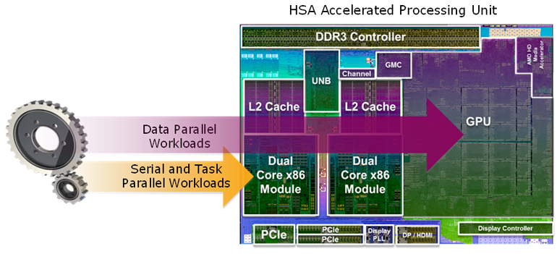Since their earliest days, computers have contained central processing units (CPUs) designed to run general programming tasks very well. But in the last couple of decades, mainstream computer systems typically include other processing elements as well. The most prevalent is the graphics processing unit (GPU), originally designed to perform specialized graphics computations in parallel. Over time, GPUs have become more powerful and more generalized, allowing them to be applied to general purpose parallel computing tasks with excellent power efficiency.

*Since their earliest days, computers have contained central processing units (CPUs) designed to run general programming tasks very well. But in the last couple of decades, mainstream computer systems typically include other processing elements as well. The most prevalent is the graphics processing unit (GPU), originally designed to perform specialized graphics computations in parallel. Over time, GPUs have become more powerful and more generalized, allowing them to be applied to general purpose parallel computing tasks with excellent power efficiency.*

*But current CPUs and GPUs have been designed as separate processing elements and do not work together efficiently…*

*Today, a growing number of mainstream applications require the high performance and power efficiency achievable only through such highly parallel computation. But current CPUs and GPUs have been designed as separate processing elements and do not work together efficiently – and are cumbersome to program. Each has a separate memory space, requiring an application to explicitly copy data from CPU to GPU and then back again*

*A program running on the CPU queues work for the GPU using system calls through a device driver stack managed by a completely separate scheduler. This introduces significant dispatch latency, with overhead that makes the process worthwhile only when the application requires a very large amount of parallel computation. Further, if a program running on the GPU wants to directly generate work-items, either for itself or for the CPU, it is impossible* today!

Navidia optimus technology

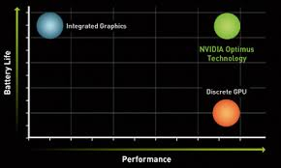Nvidia Optimus is a computer [GPU switching](https://en.m.wikipedia.org/wiki/GPU_switching) technology created by [Nvidia](https://en.m.wikipedia.org/wiki/Nvidia" \o "Nvidia) which, depending on the resource load generated by client software applications, will seamlessly switch between two graphics adapters within a computer system in order to provide either maximum performance or minimum power draw from the system's graphics rendering hardware.

**The NVIDIA Driver is the software driver for NVIDIA Graphics GPU installed on the PC. It is a program used to communicate from the Windows PC OS to the device. This software is required in most cases for the hardware device to function properly.**

Operation : When a user launches an application, the graphics [driver](https://en.m.wikipedia.org/wiki/Device_driver) tries to determine whether the application would benefit from the discrete GPU. If so, the GPU is powered up from an [idle](https://en.m.wikipedia.org/wiki/Idle_(CPU)) state and is passed all rendering calls. Even in this case, though, the integrated graphics processor (IGP) is used to output the final image. When less demanding applications are used, the IGP takes sole control, allowing for longer battery life and less fan noise. Under Windows the Nvidia driver also provides the option to manually select the GPU in the right-click menu upon launching an executable

# THE EVOLUTION OF MULTI-DISPLAY GAMING  POWERED BY GEFORCE GTX 500-SERIES GPUS

Imagine expanding your gaming real estate across three displays in full HD 3D for a completely immersive gaming experience. With the introduction of NVIDIA® GeForce®GTX 500 GPUs, you can now use award-winning NVIDIA 3D Vision® technology to build the world's first multi-display 3D gaming experience on your PC.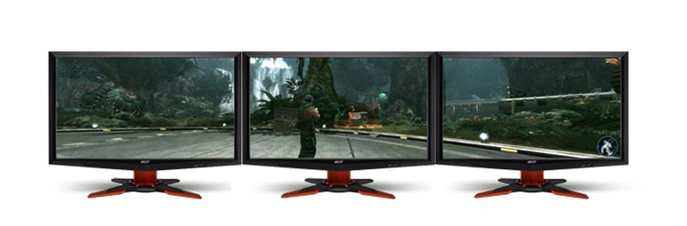

## EXPAND YOUR GAMING REAL-ESTATE  FOR THE ULTIMATE IMMERSIVE EXPERIENCE.

* Get a complete view of the battlefield in real-time strategy games.
* Manage your inventory windows, build quest logs, and track your party in your favorite MMORPGs.
* See your enemy's movement faster and react first in first-person-shooters.
* Put yourself in the driver seat of your favorite racing game and be a part of the action.

## DISCOVER 3D GAMING ACROSS THREE 1080P  DISPLAYS FOR A BREATHTAKING EXPERIENCE

* Advanced NVIDIA software automatically converts over 500 games to stereoscopic 3D without the need for special game patches.
* GeForce GTX 500 GPUs deliver the graphics horsepower to drive 750M pixels/second for screen 3 times Full HD 1080p 3D Vision gaming and an incredible 5760x1080 experience.
* It's compatible with all 3D Vision®-ready desktop monitors and projectors.

## GET UP AND GAMING IN MINUTES WITH  THE WORLD'S MOST ADVANCED MULTI-DISPLAY SOFTWARE

* It works with all standard monitor connectors, without requiring special display adapter dongles.
* A simple-to-use setup wizard guides users through setup and allows bezel correction to enable a seamless display experience.
* Advanced GPU synchronization ensures seamless support and maximum frame rate.
* Use Accessory Displays to watch movies, browse the web, or chat with friends.

## ALSO ENJOY BEST-IN-CLASS 2D SURROUND GAMING.

* Game across three non-3D displays with resolutions up to 2560x1600.
* Enjoy support for both landscape and portrait mode for ultimate display flexibility.

For a complete list of system requirements for NVIDIA Surround Technology, [click here](http://www.nvidia.com/object/3DV_System_Requirements_Surround_Technology.html).

**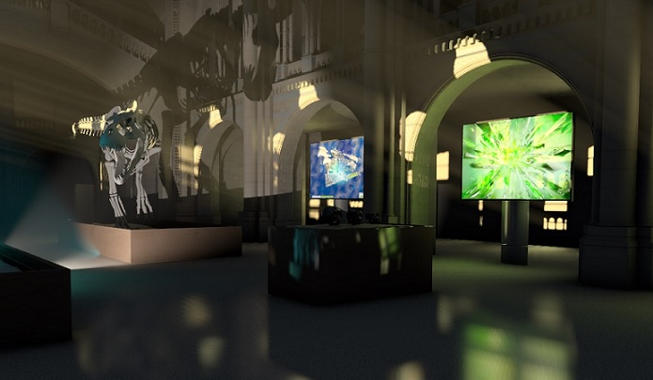Nvidia vxgi**

* *NVIDIA VXGI is an implementation of a global illumination algorithm known as Voxel Cone Tracing. Global illumination computes all lighting in the scene, including secondary reflections of light of diffuse and specular surfaces. Adding GI to the scene greatly improves the realism of the rendered images. Modern real-time rendering engines simulate indirect illumination using different approaches, which include precomputed light maps (offline GI), local light sources placed by artists, and simple ambient light.*

|  |  |
| --- | --- |
| Platforms | PC |
| Dependencies | DX11 |

**Advanced Micro Devices OR AMD**

**Advanced Micro Devices, Inc. (AMD) is an American multinational semiconductor company based in Sunnyvale, California, United States, that develops computer processors and related technologies for business and consumer markets. While initially it manufactured its own processors, the company became fabless after GlobalFoundries was spun off in 2009. AMD's main products include microprocessors, motherboard chipsets, embedded processors and graphics processors for servers, workstations and personal computers, and embedded systems applications.**

**AMD is the second-largest supplier and only significant rival to Intel in the market for x86-based microprocessors. Since acquiring ATI in 2006, AMD and its competitor Nvidia have dominated the discrete Graphics Processor Unit (GPU) market.**

**HISTORY**

**Advanced Micro Devices was formally incorporated on May 1, 1969, by Jerry Sanders, along with seven of his colleagues from Fairchild Semiconductor.[7][8] Sanders, an electrical engineer who was the director of marketing at Fairchild, had like many Fairchild executives grown frustrated with the increasing lack of support, opportunity, and flexibility within that company, and decided to leave to start his own semiconductor company.[9] The previous year Robert Noyce, who had invented the first practical integrated circuit or microchip in 1959 at Fairchild,[10] had left Fairchild together with Gordon Moore and founded the semiconductor company Intel in July 1968.[11]**

**In September 1969, AMD moved from its temporary location in Santa Clara to Sunnyvale, California.[12] To immediately secure a customer base, AMD initially became a second source supplier of microchips designed by Fairchild and National Semiconductor.[13][14] AMD first focused on producing logic chips.[15] The company guaranteed quality control to United States Military Standard, an advantage in the early computer industry since unreliability in microchips was a distinct problem that customers – including computer manufacturers, the telecommunications industry, and instrument manufacturers – wanted to avoid.[13][16][17]**

**In November 1969, the company manufactured its first product, the Am9300, a 4-bit MSI shift register, which began selling in 1970.[18][19] Also in 1970, AMD produced its first proprietary product, the Am2501 logic counter, which was highly successful.[20][21] Its best-selling product in 1971 was the Am2505, the fastest multiplier available.[20][22]**

**In 1971, AMD entered the RAM chip market, beginning with the Am3101, a 64-bit bipolar RAM.[22][23] That year AMD also greatly increased the sales volume of its linear integrated circuits, and by year end the company's total annual sales reached $4.6 million.**

**Production and fabrication**

**GlobalFoundries' main microprocessor manufacturing facilities are located in Dresden, Germany. Additionally, highly integrated microprocessors are manufactured in Taiwan made by third-party manufacturers under strict license from AMD. Between 2003 and 2005, they constructed a second manufacturing plant (300 mm 90 nm process SOI) in the same complex in order to increase the number of chips they could produce, thus becoming more competitive with Intel. The new plant was named "Fab 36", in recognition of AMD's 36 years of operation, and reached full production in mid-2007. Fab 36 was renamed to "Fab 1" during the spin-off of AMD's manufacturing business during the creation of GlobalFoundries. In July 2007, AMD announced that they completed the conversion of Fab 1 Module 1 from 90 nm to 65 nm. They then shifted their focus to the 45 nm conversion.[161]**

**In July 2016 Forbes reported that AMD had successfully produced products on Samsung's 14 nanometer FinFET process. This presents additional manufacturing opportunities, in addition to AMD's primary foundries: GlobalFoundries and TSMC.[162] It was argued this would reduce risk for AMD by decreasing dependence on any one foundry.**

**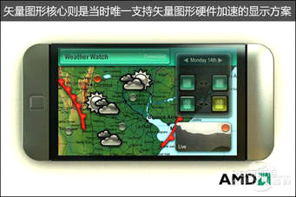**

**OTHER DEVICES**

**AMD motherboard chipsets**

**Before the launch of Athlon 64 processors in 2003, AMD designed chipsets for their processors spanning the K6 and K7 processor generations. The chipsets include the AMD-640, AMD-751 and the AMD-761 chipsets. The situation changed in 2003 with the release of Athlon 64 processors, and AMD chose not to further design its own chipsets for its desktop processors while opening the desktop platform to allow other firms to design chipsets. This was the “Open Platform Management Architecture” with ATI, VIA and SiS developing their own chipset for Athlon 64 processors and later Athlon 64 X2 and Athlon 64 FX processors, including the Quad FX platform chipset from Nvidia.**

**The initiative went further with the release of Opteron server processors as AMD stopped the design of server chipsets in 2004 after releasing the AMD-8111 chipset, and again opened the server platform for firms to develop chipsets for Opteron processors. As of today, Nvidia and Broadcom are the sole designing firms of server chipsets for Opteron processors.**

**AMD Quad FX platform**

**The AMD Quad FX platform, being an extreme enthusiast platform,[clarification needed] allows two processors to connect through HyperTransport, which is a similar setup to dual-processor (2P) servers, excluding the use of buffered memory/registered memory DIMM modules, and a server motherboard, the current setup includes two Athlon 64 FX-70 series processors and a special motherboard.[citation needed] AMD pushed the platform for the surging demands for what AMD calls "megatasking",[129] the ability to do more tasks on a single system. The platform refreshes with the introduction of Phenom FX processors and the next-generation RD790 chipset, codenamed "FASN8".**

**AMD Live!**

**As of 2007, AMD LIVE! was a platform marketing initiative focusing the consumer electronics segment, with an Active TV initiative for streaming Internet videos from web video services such as YouTube, into AMD Live! PC as well as connected digital TVs, together with a scheme for an ecosystem of certified peripherals for the ease of customers to identify peripherals for AMD LIVE! systems for digital home experience, called "AMD LIVE! Ready".[128]**

**REFERENCES**

* **AMD Headquarters. Retrieved September 24, 2011.**
* **^ Jump up to: a b "Advanced Micro Devices CEO Rory Read Steps Down". wsj.com. October 8, 2014. Retrieved October 8, 2014.**
* **Jump up ^ "AMD Memory at". Tigerdirect.com. January 3, 2011. Retrieved December 29, 2012.**
* **Jump up ^ "AMD Support Search". Retrieved December 29, 2012.**
* **^ Jump up to: a b c d e f "AMD Reports 2016 Third Quarter Results". AMD. Retrieved October 20, 2016.**
* **Jump up ^ Lilly, Paul (May 6, 2011). "Nvidia Leads in Discrete Desktop GPU Market Share, AMD in Notebook Graphics". Maximum PC. Retrieved February 18, 2012.**
* **Jump up ^ The other founding members were Ed Turney, John Carey, Sven Simonsen, Jack Gifford and three members from Gifford's team: Frank Botte, Jim Giles, and Larry Stenger.**
* **Jump up ^ Rodengen, p. 30.**
* **Jump up ^ "Fairchild's Offspring". Business Week. August 25, 1997. p. 84.**
* **Jump up ^ Mueller, Scott. Upgrading and Repairing PCs. Que Publishing, 2013. p. 6.**
* **Jump up ^ Malone, Michael S. "Silicon Insider: AMD-Intel Feud Continues". ABC News. April 24, 2003.**
* **Jump up ^ Rodengen, p. 36.**
* **^ Jump up to: a b c d Pederson, Jay P. International Directory of Company Histories, Vol. 30. St. James Press, 2000.**
* **Jump up ^ Rodengen, p. 35.**
* **Jump up ^ Rodengen, pp. 37–38.**
* **^ Jump up to: a b c Singer, Graham. "The Rise and Fall of AMD". TechSpot. November 21, 2012.**

**AUGMENTED REALITY OR AR**

**Augmented reality (AR) is a live direct or indirect view of a physical, real-world environment whose elements are augmented (or supplemented) by computer-generated sensory input such as sound, video, graphics or GPS data. It is related to a more general concept called mediated reality, in which a view of reality is modified (possibly even diminished rather than augmented) by a computer. As a result, the technology functions by enhancing one’s current perception of reality.[1] By contrast, virtual reality replaces the real world with a simulated one.[2][3] Augmentation is conventionally in real time and in semantic context with environmental elements, such as sports scores on TV during a match. With the help of advanced AR technology (e.g. adding computer vision and object recognition) the information about the surrounding real world of the user becomes interactive and digitally manipulable. Information about the environment and its objects is overlaid on the real world. This information can be virtual[4][5][6][7][8] or real, e.g. seeing other real sensed or measured information such as electromagnetic radio waves overlaid in exact alignment with where they actually are in space.**

**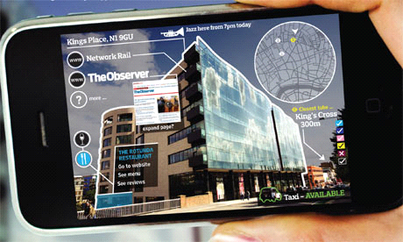**

**HISTORY**

* **1901: L. Frank Baum, an author, first mentions the idea of an electronic display/spectacles that overlays data onto real life (in this case 'people'), it is named a 'character marker'.[228]**
* **1957–62: Morton Heilig, a cinematographer, creates and patents a simulator called Sensorama with visuals, sound, vibration, and smell.[229]**
* **1968: Ivan Sutherland invents the head-mounted display and positions it as a window into a virtual world.[230]**
* **1975: Myron Krueger creates Videoplace to allow users to interact with virtual objects for the first time.**
* **1980: Steve Mann creates the first wearable computer, a computer vision system with text and graphical overlays on a photographically mediated reality, or Augmediated Reality.[231] See EyeTap.**
* **1981: Dan Reitan geospatially maps multiple weather radar images and space-based and studio cameras to virtual reality Earth maps and abstract symbols for television weather broadcasts, bringing Augmented Reality to TV.[232]**
* **1987: Douglas George and Robert Morris create a working prototype of an astronomical telescope-based AR system which superimposed in the telescope eyepiece, over the actual sky images, multi-intensity star and celestial body images, and other relevant information.[233][234]**
* **1989: Jaron Lanier coins the phrase Virtual Reality and creates the first commercial business around virtual worlds.**
* **1990: The term 'Augmented Reality' is attributed to Thomas P. Caudell, a former Boeing researcher.[235]**
* **1992: Louis Rosenberg develops one of the first functioning AR systems, called Virtual Fixtures, at the U.S. Air Force Research Laboratory—Armstrong, and demonstrates benefits to human performance.[218][221][236]**
* **1992: Steven Feiner, Blair MacIntyre and Doree Seligmann present the first major paper on an AR system prototype, KARMA, at the Graphics Interface conference.**
* **1993: Mike Abernathy, et al., report the first use of augmented reality in identifying space debris using Rockwell WorldView by overlaying satellite geographic trajectories on live telescope video.[158]**
* **1993 A widely cited version of the paper above is published in Communications of the ACM – Special issue on computer augmented environments, edited by Pierre Wellner, Wendy Mackay, and Rich Gold.[237]**
* **2008: Wikitude AR Travel Guide launches on 20 Oct 2008 with the G1 Android phone.[240]**
* **2009: ARToolkit was ported to Adobe Flash (FLARToolkit) by Saqoosha, bringing augmented reality to the web browser.[241]**
* **2012: Launch of Lyteshot, an interactive AR gaming platform that utilizes smartglasses for game data**
* **2013: Meta announces the Meta 1 developer kit, the first to market AR see-through display[citation needed]**
* **2013: Google announces an open beta test of its Google Glass augmented reality glasses. The glasses reach the Internet through Bluetooth, which connects to the wireless service on a user’s cellphone. The glasses respond when a user speaks, touches the frame or moves the head.[242]**
* **2014: Mahei creates the first generation of augmented reality enhanced educational toys.[243]**
* **2015: Microsoft announces Windows Holographic and the HoloLens augmented reality headset. The headset utilizes various sensors and a processing unit to blend high definition "holograms" with the real world.[244]**
* **2016: Niantic released Pokémon Go for iOS and Android in July 2016. The game quickly became one of the most used applications and has brought augmented reality to the mainstream.[245]**

**Technology**

**Hardware**

**Hardware components for augmented reality are: processor, display, sensors and input devices. Modern mobile computing devices like smartphones and tablet computers contain these elements which often include a camera and MEMS sensors such as accelerometer, GPS, and solid state compass, making them suitable AR platforms.[14]**

**Display**

**Various technologies are used in Augmented Reality rendering including optical projection systems, monitors, hand held devices, and display systems worn on the human body.**

**HEAD MOUNTED**

**A head-mounted display (HMD) is a display device paired to the forehead such as a harness or helmet. HMDs place images of both the physical world and virtual objects over the user's field of view. Modern HMDs often employ sensors for six degrees of freedom monitoring that allow the system to align virtual information to the physical world and adjust accordingly with the user's head movements.[15][16][17] HMDs can provide VR users mobile and collaborative experiences.[18] Specific providers, such as uSens and Gestigon, are even including gesture controls for full virtual immersion.[19][20]**

**Eyeglasses**

**AR displays can be rendered on devices resembling eyeglasses. Versions include eyewear that employ cameras to intercept the real world view and re-display its augmented view through the eye pieces[28] and devices in which the AR imagery is projected through or reflected off the surfaces of the eyewear lens pieces.[29][30][31]**

**HUD**

**Near eye augmented reality devices can be used as portable head-up displays as they can show data, information, and images while the user views the real world. Many definitions of augmented reality only define it as overlaying the information.[32][33] This is basically what a head-up display does; however, practically speaking, augmented reality is expected to include tracking between the superimposed information, data, and images and some portion of the real world.**

**APPLICATIONS**

**Literature**

**In 2011, AR was blended with poetry by ni ka from Sekai Camera in Japan, Tokyo. The prose of these AR poems come from Paul Celan, "Die Niemandsrose", expressing the mourning of "3.11," March 2011 Tōhoku earthquake and tsunami.[82][83][84][85]**

**Archaeology**

**AR was applied to aid archaeological research. By augmenting archaeological features onto the modern landscape, AR allowed archaeologists to formulate possible site configurations from extant structures.[86]**

**Architecture**

**AR can aid in visualizing building projects. Computer-generated images of a structure can be superimposed into a real life local view of a property before the physical building is constructed there; this was demonstrated publicly by Trimble Navigation in 2004. AR can also be employed within an architect's work space, rendering into their view animated 3D visualizations of their 2D drawings. Architecture sight-seeing can be enhanced with AR applications allowing users viewing a building's exterior to virtually see through its walls, viewing its interior objects and layout.[90][91][92]**

**VIDEO GAMES**

**Augmented reality allowed video game players to experience digital game play in a real world environment. Companies and platforms like Niantic and LyteShot emerged as major augmented reality gaming creators.[130][131] Niantic is notable for releasing the record-breaking Pokémon Go game.[132] However, though the popular press overwhelmingly calls Pokémon Go an augmented reality game, most experts in AR and experts in game development agree that it is best described as a location-based game.[133][134][135][136][137][138][139][140][141**

**NAVIGATION**

**Augmented reality allowed video game players to experience digital game play in a real world environment. Companies and platforms like Niantic and LyteShot emerged as major augmented reality gaming creators.[130][131] Niantic is notable for releasing the record-breaking Pokémon Go game.[132] However, though the popular press overwhelmingly calls Pokémon Go an augmented reality game, most experts in AR and experts in game development agree that it is best described as a location-based game.[133][134][135][136][137][138][139][140]**

**REFERENCES**

* **Graham, M., Zook, M., and Boulton, A. "Augmented reality in urban places: contested content and the duplicity of code." Transactions of the Institute of British Geographers, DOI: 10.1111/j.1475-5661.2012.00539.x 2012.**
* **Jump up ^ Steuer, Jonathan. Defining Virtual Reality: Dimensions Determining Telepresence, Department of Communication, Stanford University. 15 October 1993.**
* **Jump up ^ Introducing Virtual Environments National Center for Supercomputing Applications, University of Illinois.**
* **Jump up ^ Chen, Brian X. If You’re Not Seeing Data, You’re Not Seeing, Wired, 25 August 2009.**
* **Jump up ^ Maxwell, Kerry. Augmented Reality, Macmillan Dictionary Buzzword.**
* **Jump up ^ Augmented reality-Everything about AR, Augmented Reality On.**
* **^ Jump up to: a b Azuma, Ronald. A Survey of Augmented Reality Presence: Teleoperators and Virtual Environments, pp. 355–385, August 1997.**
* **Jump up ^ Zhanpeng, H.,Pan H., et al. Mobile augmented reality survey: a bottom-up approach.**
* **Jump up ^ Phenomenal Augmented Reality, IEEE Consumer Electronics, Volume 4, No. 4, October 2015, cover+pp92-97**

APP

**AR AND HUD**

**HUD OR Head-up display**

**A head-up display or heads-up display,[1] also known as a HUD, is any transparent display that presents data without requiring users to look away from their usual viewpoints. The origin of the name stems from a pilot being able to view information with the head positioned "up" and looking forward, instead of angled down looking at lower instruments. A HUD also has the advantage that the pilot's eyes do not need to refocus to view the outside after looking at the optically nearer instruments.**

**maneuvering.**

**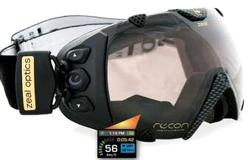**

**HISTORY**

**During the early 1940s, the Telecommunications Research Establishment (TRE), in charge of UK radar development, found that Royal Air Force (RAF) night fighter pilots were having a hard time reacting to the verbal instruction of the radar operator as they approached their targets. They experimented with the addition of a second radar display for the pilot, but found they had trouble looking up from the lit screen into the dark sky in order to find the target. In October 1942 they had successfully combined the image from the radar tube with a projection from their standard GGS Mk. II gyro gunsight on a flat area of the windscreen.[4] A key upgrade was the move from the original AI Mk. IV radar to the microwave-frequency AI Mk. VII radar found on the de Havilland Mosquito night fighter. This set produced an artificial horizon that further eased head-up flying.[5]**

**Until a few years ago, the Embraer 190, Saab 2000, Boeing 727, Boeing 737-300, 400, 500 and Boeing 737 New Generation Aircraft (737-600,700,800, and 900 series) were the only commercial passenger aircraft available with HUDs. However, the technology is becoming more common with aircraft such as the Canadair RJ, Airbus A318 and several business jets featuring the displays. HUDs have become standard equipment on the Boeing 787.[10] Furthermore, the Airbus A320, A330, A340 and A380 families are currently undergoing the certification process for a HUD.[11] HUDs were also added to the Space Shuttle orbiter.**

**INTERNAL STRUCTURE**

**A typical HUD contains three primary components: a projector unit, a combiner, and a video generation computer.[2]**

**The projection unit in a typical HUD is an optical collimator setup: a convex lens or concave mirror with a Cathode Ray Tube, light emitting diode, or liquid crystal display at its focus. This setup (a design that has been around since the invention of the reflector sight in 1900) produces an image where the light is collimated, i.e. the focal point is perceived to be at infinity.**

**The combiner is typically an angled flat piece of glass (a beam splitter) located directly in front of the viewer, that redirects the projected image from projector in such a way as to see the field of view and the projected infinity image at the same time. Combiners may have special coatings that reflect the monochromatic light projected onto it from the projector unit while allowing all other wavelengths of light to pass through. In some optical layouts combiners may also have a curved surface to refocus the image from the projector.**

**Types**

**Other than fixed mounted HUDs, there are also head-mounted displays (HMDs). Including helmet mounted displays (both abbreviated HMD), forms of HUD that features a display element that moves with the orientation of the user's head.**

**Many modern fighters (such as the F/A-18, F-16 and Eurofighter) use both a HUD and HMD concurrently. The F-35 Lightning II was designed without a HUD, relying solely on the HMD, making it the first modern military fighter not to have a fixed HUD.**

**Generations**

**HUDs are split into four generations reflecting the technology used to generate the images.**

* **First Generation—Use a CRT to generate an image on a phosphor screen, having the disadvantage of the phosphor screen coating degrading over time. The majority of HUDs in operation today are of this type.**
* **Second Generation—Use a solid state light source, for example LED, which is modulated by an LCD screen to display an image. These systems do not fade or require the high voltages of first generation systems. These systems are on commercial aircraft.**
* **Third Generation—Use optical waveguides to produce images directly in the combiner rather than use a projection system.**
* **Fourth Generation—Use a scanning laser to display images and even video imagery on a clear transparent medium.**

**APPLICATIONS**

***Aircraft***

**In addition to the generic information described above, military applications include weapons system and sensor data such as:**

**• target designation (TD) indicator—places a cue over an air or ground target (which is typically derived from radar or inertial navigation system data). • Vc—closing velocity with target. • Range—to target, waypoint, etc. • weapon seeker or sensor line of sight—shows where a seeker or sensor is pointing. • weapon status—includes type and number of weapons selected, available, arming, etc.**

**Automobiles**

**In 2012 Pioneer Corporation introduced a HUD navigation system that replaces the driver side sun visor and visually overlays animations of conditions ahead; a form of augmented reality (AR).[26][27] Developed by Pioneer Corporation, AR-HUD became the first aftermarket automotive Head-Up Display to use a direct-to-eye laser beam scanning method, also known as virtual retinal display (VRD). AR-HUD's core technology involves a miniature laser beam scanning display developed by MicroVision, Inc.[28].**

**Motorcycle helmet HUDs are also commercially available.[29]**

**REFERENCES**

**• Oxford Dictionary of English, Angus Stevenson, Oxford University Press – 2010, page 809 (head-up display (N.Amer. also heads-up display))Jump up ^ Fred H. Previc; William R. Ercoline. Spatial disorientation in aviation. Books.google.com. p. 452. Retrieved 2012-07-14.• Jump up ^ D. N. Jarrett (2005). Cockpit engineering. Ashgate Pub. p. 189. ISBN 0-7546-1751-3. ISBN 9780754617518. Retrieved 2012-07-14. • Jump up ^ Ian White, "The History of Air Intercept Radar & the British Nightfigher", Pen & Sword, 2007, p. 207 • Jump up ^ "Axis History Forum • View topic – RAF Fixed and Free-mounted Reflector Gunsights". Forum.axishistory.com. Retrieved 2009-12-08.**

**AUGMENT REALITY IN SMART PHONES**

**Augment is an augmented reality SaaS platform that allows users to visualize their products in 3D in real environment and in real-time through tablets or smartphones. The software can be used for Retail, E-Commerce, architecture, and other purposes.**

**Augment created a mobile app of the same name, used to visualize 3D models in augmented reality[1] and a web application called Augment Manager for 3D content management. The company is based in Paris, France and was founded in October 2011 by Jean-François Chianetta, Cyril Champier and Mickaël Jordan. In March 2016, Augment announced €3 million in its Series A round from Salesforce Ventures,[1] which bringing the total funding since launch to $4.7 million.**

**Augment lets businesses and 3D professionals visualize projects in their actual size and environment, on iPhone, iPad and Android,[2] using the power of Augmented Reality. Users can print the Augment tracker or create their own tracker to place the 3D models in space and at scale in real time. Common uses of the technology include product presentations,[3] interactive print campaigns and e-Commerce product visualization**

**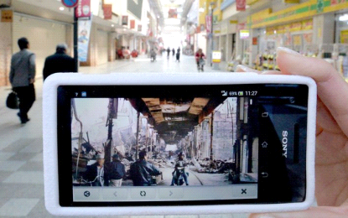**

**HISTORY**

**Augment was first created by Jean-François Chianetta in October 2011. Chianetta later teamed up with Cyril Champier and Mickaël Jordan for further development.[5][6] The co-founding team was among the 12 startups of Season 3 of French accelerator Le Camping.[7] The team raised one million euros (US$1,300,000) in April 2013[8] and moved its office to Paris. In March 2016, Augment raised US$3M Series A funding from Salesforce and other investors.[9]**

**In 2013, Augment's first service, Boost Business Catalog, was made available to help businesses catalogue and display their product models.[10][11] Customers can rotate the images in 3D and view augmented content before deciding what to buy.[12]**

**Technology**

**Augment uses the following 3D technologies:**

* **Vuforia Augmented Reality SDK**
* **OpenGL**

***APPLICATIONS***

**Augmented reality has many applications. First used for military, industrial, and medical applications, by 2012 its use expanded into entertainment and other commercial industries.[80] By 2016, powerful mobile devices allowed AR to become a useful learning aid even in primary schools.**

**Since the 1970s and early 1980s, Steve Mann has been developing technologies meant for everyday use i.e. "horizontal" across all applications rather than a specific "vertical" market. Examples include Mann's "EyeTap Digital Eye Glass", a general-purpose seeing aid that does dynamic-range management (HDR vision) and overlays, underlays, simultaneous augmentation and diminishment (e.g. diminishing the electric arc while looking at a welding torch).[81**

**AR IN IPHONE**

**AR IN iA month ago, we covered Wikitude, an augmented reality app for Google Android. Augmented reality takes virtual data, places it on your phone, and allows you to interact with it using your compass, camera, and GPS. The end result is the ability to see virtual items and information in the real world.**

**Wikitude's AR app combines Wikipedia and geotagged information from its users and places it in your hands. But while it's been on Android for some time, it hasn't been on the iPhone. That's because has Apple has only recently begun to accept AR on the iPhone, inadvertently starting with Yelp's easter egg.Phone**

**Apple's been slowly opening the doors to more and more AR apps, but Wikitude is one we've specifically been waiting for. There are just so many possibilities with augmented reality that we can't help but be excited about this development and the future of AR.**

**Video Games**

**The gaming industry embraced AR technology. A number of games were developed for prepared indoor environments, such as AR air hockey, collaborative combat against virtual enemies, and AR-enhanced pool-table games.[128][129]**

**Augmented reality allowed video game players to experience digital game play in a real world environment. Companies and platforms like Niantic and LyteShot emerged as major augmented reality gaming creators.[130][131] Niantic is notable for releasing the record-breaking Pokémon Go game.[132] However, though the popular press overwhelmingly calls Pokémon Go an augmented reality game, most experts in AR and experts in game development agree that it is best described as a location-based game.**

**REFERENCES**

* **Donovan, Jay. "Augment raises over $3 million in series A funding from Salesforce Ventures". TechCrunch. Retrieved 2016-12-05. • Jump up ^ Top 20 Augmented Reality Apps for Android and iPhone / iPad users, DeepKnowHow, 2013-04-04 • Jump up ^ Augment makes Augmented Reality useful for salespeople with its new Business Catalog, Techcrunch, 2013-08-30 • Jump up ^ "Success Stories using Augmented Reality App - Augment". Augment. Retrieved 2016-10-10. • Jump up ^ French startup helps Augmented Reality grow up, Forbes, 2012-07-14 • Jump up ^ "La réalité augmentée tente une seconde jeunesse en entreprise". Clubic (in French). • Jump up ^ "Heureux comme un patron de start-up en France". LE MONDE | 17.10.2012 by Cécile Ducourtieux and Audrey Tonnelier. • Jump up ^ "Augment lève un million d'euros pour son application de réalité augmentée". Journal du Net**

**AUGMENTED REALITY IN VR**

*AUGMENTED REALITY*

**Augmented reality (AR) is a technology that layers computer-generated enhancements atop an existing reality in order to make it more meaningful through the ability to interact with it. AR is developed into apps and used on mobile devices to blend digital components into the real world in such a way that they enhance one another, but can also be told apart easily.**

**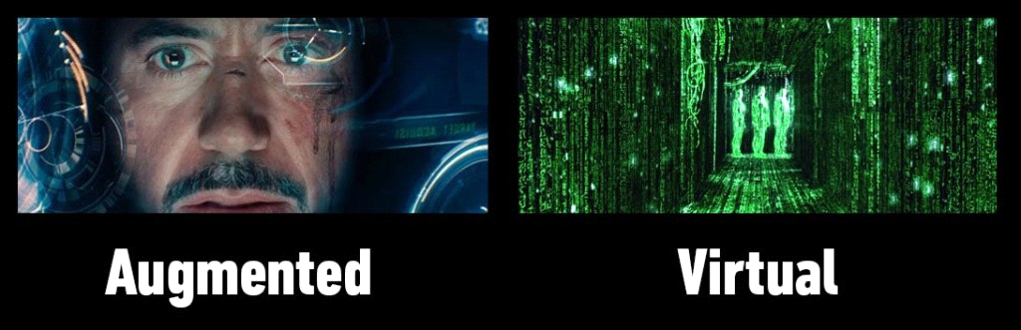**

***USES***

***AR technology is quickly coming into the mainstream. It is used to display score overlays on telecasted sports games and pop out 3D emails, photos or text messages on mobile devices. Leaders of the tech industry are also using AR to do amazing and revolutionary things with holograms and motion activated commands.***

*VERTUAL REALITY*

**Virtual reality (VR) is an artificial, computer-generated simulation or recreation of a real life environment or situation. It immerses the user by making them feel like they are experiencing the simulated reality firsthand, primarily by stimulating their vision and hearing.**

**USES**

**VR is typically achieved by wearing a headset like Facebook’s Oculus equipped with the technology, and is used prominently in two different ways:**

* **To create and enhance an imaginary reality for gaming, entertainment, and play (Such as video and computer games, or 3D movies, head mounted display).**
* **To enhance training for real life environments by creating a simulation of reality where people can practice beforehand (Such as flight simulators for pilots).**

**Augmented Reality vs. Virtual Reality**

**Augmented reality and virtual reality are inverse reflections of one in another with what each technology seeks to accomplish and deliver for the user. Virtual reality offers a digital recreation of a real life setting, while augmented reality delivers virtual elements as an overlay to the real world.**

**SIMILARITIES**

*TECHNOLOGY*

**Augmented and virtual realities both leverage some of the same types of technology, and they each exist to serve the user with an enhanced or enriched experience**

*ENTERTAINMENT*

**Both technologies enable experiences that are becoming more commonly expected and sought after for entertainment purposes. While in the past they seemed merely a figment of a science fiction imagination, new artificial worlds come to life under the user’s control, and deeper layers of interaction with the real world are also achievable. Leading tech moguls are investing and developing new adaptations, improvements, and releasing more and more products and apps that support these technologies for the increasingly savvy users.**

**DIFFERENCE**

*PURPOSE*

**Augmented reality enhances experiences by adding virtual components such as digital images, graphics, or sensations as a new layer of interaction with the real world. Contrastingly, virtual reality creates its own reality that is completely computer generated and driven.**

*Delivery Method*

**Virtual Reality is usually delivered to the user through a head-mounted, or hand-held controller. This equipment connects people to the virtual reality, and allows them to control and navigate their actions in an environment meant to simulate the real world.**

**How do they work together?**

**It is not always virtual reality vs. augmented reality– they do not always operate independently of one another, and in fact are often blended together to generate an even more immersing experience. For example, haptic feedback-which is the vibration and sensation added to interaction with graphics-is considered an augmentation. However, it is commonly used within a virtual reality setting in order to make the experience more lifelike though touch.**

**Virtual reality and augmented reality are great examples of experiences and interactions fueled by the desire to become immersed in a simulated land for entertainment and play, or to add a new dimension of interaction between digital devices and the real world. Alone or blended together, they are undoubtedly opening up worlds-both real and virtual alike.**

**References**

* *Graham, M., Zook, M., and Boulton, A. "Augmented reality in urban places: contested content and the duplicity of code." Transactions of the Institute of British Geographers, DOI: 10.1111/j.1475-5661.2012.00539.x 2012.*
* *Jump up ^ Steuer, Jonathan. Defining Virtual Reality: Dimensions Determining Telepresence, Department of Communication, Stanford University. 15 October 1993.*
* *Jump up ^ Introducing Virtual Environments National Center for Supercomputing Applications, University of Illinois.*
* *Jump up ^ Chen, Brian X. If You’re Not Seeing Data, You’re Not Seeing, Wired, 25 August 2009.*
* *Jump up ^ Maxwell, Kerry. Augmented Reality, Macmillan Dictionary Buzzword.*

**Central processing unit**

**A central processing unit (CPU) is the electronic circuitry within a computer that carries out the instructions of a computer program by performing the basic arithmetic, logical, control and input/output (I/O) operations specified by the instructions. The computer industry has used the term "central processing unit" at least since the early 1960s.[1] Traditionally, the term "CPU" refers to a processor, more specifically to its processing unit and control unit (CU), distinguishing these core elements of a computer from external components such as main memory and I/O circuitry.[2]**

**HISTORY**

**Early computers such as the ENIAC had to be physically rewired to perform different tasks, which caused these machines to be called "fixed-program computers".[5] Since the term "CPU" is generally defined as a device for software (computer program) execution, the earliest devices that could rightly be called CPUs came with the advent of the stored-program computer.**

**The idea of a stored-program computer was already present in the design of J. Presper Eckert and John William Mauchly's ENIAC, but was initially omitted so that it could be finished sooner.[6] On June 30, 1945, before ENIAC was made, mathematician John von Neumann distributed the paper entitled First Draft of a Report on the EDVAC. It was the outline of a stored-program computer that would eventually be completed in August 1949.[7] EDVAC was designed to perform a certain number of instructions (or operations) of various types. Significantly, the programs written for EDVAC were to be stored in high-speed computer memory rather than specified by the physical wiring of the computer.[8] This overcame a severe limitation of ENIAC, which was the considerable time and effort required to reconfigure the computer to perform a new task. With von Neumann's design, the program that EDVAC ran could be changed simply by changing the contents of the memory. EDVAC, however, was not the first stored-program computer; the Manchester Small-Scale Experimental Machine, a small prototype stored-program computer, ran its first program on 21 June 1948[9] and the Manchester Mark 1 ran its first program during the night of 16–17 June 1949.[10]**

**Structure and implementation**

**Hardwired into a CPU's circuitry is a set of basic operations it can perform, called an instruction set. Such operations may involve, for example, adding or subtracting two numbers, comparing two numbers, or jumping to a different part of a program. Each basic operation is represented by a particular combination of bits, known as the machine language opcode; while executing instructions in a machine language program, the CPU decides which operation to perform by "decoding" the opcode. A complete machine language instruction consists of an opcode and, in many cases, additional bits that specify arguments for the operation (for example, the numbers to be summed in the case of an addition operation). Going up the complexity scale, a machine language program is a collection of machine language instructions that the CPU executes.**

**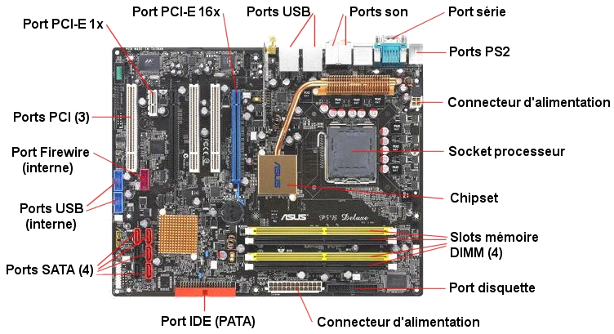**

**3.1 Control unit**

**3.2 Arithmetic logic unit**

**3.3 Memory management unit**

**3.4 Clock rate**

**3.5 Integer range**

**3.6 Parallelism**

**3.6.1 Instruction-level parallelism**

**3.6.2 Task-level parallelism**

**3.6.3 Data pa**

**WORKING**

**Nearly all CPUs follow the fetch, decode and execute steps in their operation, which are collectively known as the instruction cycle.**

**After the execution of an instruction, the entire process repeats, with the next instruction cycle normally fetching the next-in-sequence instruction because of the incremented value in the program counter. If a jump instruction was executed, the program counter will be modified to contain the address of the instruction that was jumped to and program execution continues normally. In more complex CPUs, multiple instructions can be fetched, decoded, and executed simultaneously. This section describes what is generally referred to as the "classic RISC pipeline", which is quite common among the simple CPUs used in many electronic devices (often called microcontroller). It largely ignores the important role of CPU cache, and therefore the access stage of the pipeline.**

**VIRTUAL CPU**

**Cloud computing can involve subdividing CPU operation into virtual central processing units[56] (vCPUs[57]).**

**A host is the virtual equivalent of a physical machine, on which a virtual system is operating.[58] When there are several physical machines operating in tandem and managed as a whole, the grouped computing and memory resources form a cluster. In some systems it is possible to dynamically add and remove from a cluster. Resources available at a host and cluster level can be partitioned out into resources pools with fine granularity.**

**REFERENCES**

* **Weik, Martin H. (1961). "A Third Survey of Domestic Electronic Digital Computing Systems". Ballistic Research Laboratory. • Jump up ^ Kuck, David (1978). Computers and Computations, Vol 1. John Wiley & Sons, Inc. p. 12. ISBN 0471027162. • ^ Jump up to: a b Thomas Willhalm; Roman Dementiev; Patrick Fay (December 18, 2014). "Intel Performance Counter Monitor – A better way to measure CPU utilization". software.intel.com. Retrieved February 17, 2015. • Jump up ^ Liebowitz, Kusek, Spies, Matt, Christopher, Rynardt (2014). VMware vSphere Performance: Designing CPU, Memory, Storage, and Networking for Performance-Intensive Workloads. Wiley. p. 68. ISBN 978-1-118-00819-5. • Jump up ^ Regan, Gerard. A Brief History of Computing. p. 66. ISBN 1848000839. Retrieved 26 November 2014. • Jump up ^ "Bit By Bit". Haverford College. Archived from the original on October 13, 2012. Retrieved August 1, 2015. • Jump up ^ "First Draft of a Report on the EDVAC" (PDF). Moore School of Electrical Engineering, University of Pennsylvania. 1945. • Jump up ^ Stanford University. "The Modern History of Computing". The Stanford Encyclopedia of Philosophy. Retrieved September 25, 2015.**

**HTC VIVE**

**HTC Vive is a virtual reality headset developed by HTC and Valve Corporation, released on 5 April 2016. This headset is designed to utilize "room scale" technology to turn a room into 3D space via sensors, with the virtual world allowing the user to navigate naturally, with the ability to walk around and use motion tracked handheld controllers to vividly manipulate objects, interact with precision, communicate and experience immersive environments.[5]**

**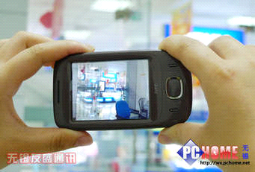**

**HISTORY**

**During his Immersed 2015 keynote, Phil Chen, Chief Content Officer for HTC and Founder of the HTC Vive explained that he "stumbled upon VR" and later HTC met Valve, which turned out to be "serendipity".[13] Chen also explained that HTC and Valve don't have a clear dividing line between each of their responsibilities, and HTC is very much a partner in the research and development process.[14]**

**DEVELOPMENT**

**Prototypes of a Valve-produced virtual reality system were demonstrated during 2014. On 23 February 2015, Valve announced that it would demonstrate a "SteamVR hardware system" at the 2015 Game Developers Conference.[6][7][8] HTC officially unveiled its device, Vive, during its Mobile World Congress keynote on 1 March 2015.[5] Preorders started on 29 February 2016 at 10:00 a.m. EST.[9] Valve and HTC have since announced that the headset will be free for selected developers.[10]At Consumer Electronics Show 2016, HTC and Valve unveiled a near-final hardware revision of the device, known as HTC Vive Pre.[11]**

**INTERNAL STRUCTURE**

**The Vive has a refresh rate of 90 Hz. The device uses two screens, one per eye, each having a display resolution of 1080x1200.[16] The device uses more than 70 sensors including a MEMS (Microelectromechanical systems) gyroscope, accelerometer and laser position sensors, and is said to operate in a 15-by-15-foot (4.6 by 4.6 m) tracking space if used with both "Lighthouse" base stations that track the user's movement with sub-millimeter precision.[17] The Lighthouse system was designed by Alan Yates and uses simple photosensors on any object that needs to be captured; to avoid occlusion problems this is combined with two lighthouse stations that sweep structured light lasers within a space.[18]**

**USE IN GAMES OR VR**

**Main article: List of HTC Vive games**

**By March 2016, the time at which the pre-orders for the HTC Vive opened, 107 games were known to be coming to the virtual reality format.[20]On 30 April 2015, Epic Games announced support for Valve's SteamVR technology, allowing developers to create VR projects with Unreal Engine 4 for the HTC Vive.[24][25] Epic said that SteamVR is completely integrated into Unreal Engine 4 across Blueprint visual scripting and native code, meaning projects can be built without being dependent on programmer support if needed.[26] Epic's own Showdown tech demo can already be experienced on SteamVR using the Vive headset.[27][28] jMonkeyEngine, a free cross-platform 3D engine, is also getting support for OpenVR and the Vive.[29] Elite: Dangerous, a space exploration and trading game, added Vive support in April 201**

**INTEL HYPER THREAD-TECHONOLGY**

Hyper-threading (officially called Hyper-Threading Technology or HT Technology, and abbreviated as HTT or HT) is Intel's proprietary simultaneous multithreading (SMT) implementation used to improve parallelization of computations (doing multiple tasks at once) performed on x86 microprocessors. It first appeared in February 2002 on Xeon server processors and in November 2002 on Pentium 4 desktop CPUs.[4] Later, Intel included this technology in Itanium, Atom, and Core 'i' Series CPUs, among others.

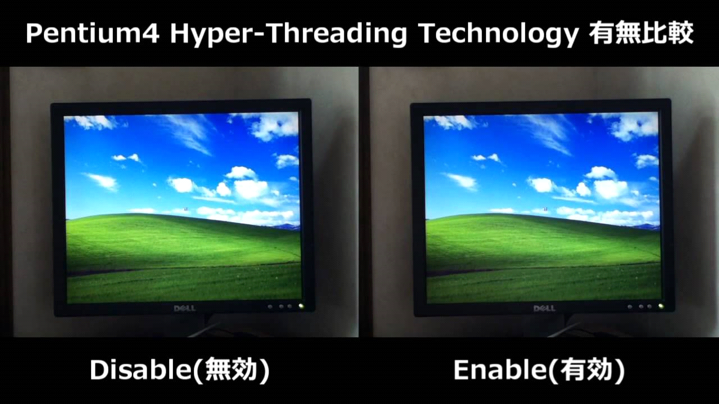

**HISTORY**

**Denelcor, Inc. introduced multi-threading with the HEP (Heterogeneous Element Processor) in 1982. The HEP pipeline could not hold multiple instructions that belong to the same process. Only one instruction from a given process was allowed to be present in the pipeline at any point in time. Should an instruction from a given process block in the pipe, instructions from the other processes would continue after the pipeline drained.**

**US patent for the technology behind hyper-threading was granted to Kenneth Okin at Sun Microsystems in November 1994. Back at the time, CMOS process technology was not advanced enough to allow for a cost-effective implementation.[8]**

**Intel implemented hyper-threading on an x86 architecture processor in 2002 with the Foster MP-based Xeon. It was also included on the 3.06 GHz Northwood-based Pentium 4 in the same year, and then remained as a feature in every Pentium 4 HT, Pentium 4 Extreme Edition and Pentium Extreme Edition processor since. Previous generations of Intel's processors based on the Core microarchitecture do not have Hyper-Threading, because the Core microarchitecture is a descendant of the P6 microarchitecture used in iterations of Pentium since the Pentium Pro through the Pentium III and the Celeron (Covington, Mendocino, Coppermine and Tualatin-based) and the Pentium II Xeon and Pentium III Xeon models.**

**WORKING**

**Hyper-threading works by duplicating certain sections of the pro**

**cessor—those that store the architectural state—but duplicating the main execution resources. This allows a hyper-threading processor to appear as the usual "physical" processor and an extra "logical" processor to the host operating system (HTT-unaware operating systems see two "physical" processors), allowing the operating system to schedule two threads or processes simultaneously and appropriately. When execution resources would not be used by the current task in a processor without hyper-threading, and especially when the processor is stalled, a hyper-threading equipped processor can use those execution resources to execute another scheduled task. (The processor may stall due to a cache miss, branch misprediction, or data dependency.)[citation needed]**

**This technology is transparent to operating systems and programs. The minimum that is required to take advantage of hyper-threading is symmetric multiprocessing (SMP) support in the operating system, as the logical processors appear as standard separate processors.**

**APPLICATIONS**

**Strictly speaking, Hyper-Threading is best applied to operations and applications where multiple tasks can be intelligently scheduled so there's no idle time on your processor. Tasks like video editing, 3D rendering, and heavy multi-tasking are great examples. Similarly, Hyper Threading can help a CPU push light tasks like background applications or browser windows to one processor, while heavy applications like games or full-screen video goes to another.**

**On the other hand, operations where tasks have to be done in serial, or where one operation has to take place before another can begin, generally don't benefit from Hyper-Threading. Whether you have a single core or a quad core, Hyper-Threading can optimize tasks that can be conducted in parallel so the whole operation is faster—but it's not the same as or even similar to increasing your number of processing cores. It does come with downsides and power consumption, for example), but the benefits usuall.**

**REFERENCES**

* **Jon Stokes (2002-10-03). "Introduction to Multithreading, Superthreading a**
* **Hyperthreading". Ars Technica. pp. 2–3. Retrieved 2015-09-30. • Jump up ^ Deborah T. Marr; Frank Binns; David L. Hill; Glenn Hinton; David A. Koufaty; J. Alan Miller; Michael Upton (2006-12-12). "Hyper-Threading Technology Architecture and Microarchitecture" (PDF). cs.sfu.ca. Retrieved 2015-09-30. • Jump up ^ Anand Lal Shimpi (2012-10-05). "The Haswell Front End – Intel's Haswell Architecture Analyzed". AnandTech. Retrieved 2015-09-30. • Jump up ^ "Intel Pentium 4 3.06GHz CPU with Hyper-Threading Technology: Killing Two Birds with a Stone...". X-bit labs. Retrieved 2014-06-04.**

**Infinadeck**

**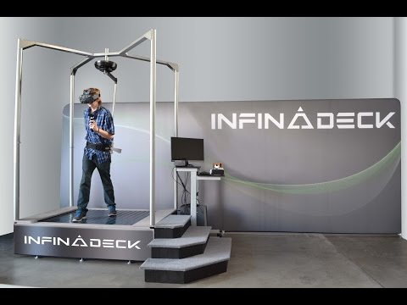**n **omnidirectional treadmill** (**ODT**) is a mechanical device, similar to a typical treadmill, that allows a person to perform locomotive motion in any direction, allowing for 360 degrees of movement. The ability to move in any direction is how these [treadmills](https://en.wikipedia.org/wiki/Treadmill) differ from their basic counterparts (that permit only unidirectional [locomotion](https://en.wikipedia.org/wiki/Animal_locomotion)). Omnidirectional treadmills are employed in [immersive](https://en.wikipedia.org/wiki/Immersion_(virtual_reality)) [virtual environment](https://en.wikipedia.org/wiki/Virtual_environment) implementations to allow unencumbered movement within the virtual space.[[1]](https://en.wikipedia.org/wiki/Omnidirectional_treadmill#cite_note-1)

Advantages to pairing an ODT with an immersive virtual environment include:

* Natural navigational movement of the system user within the enclosure while still providing [contextual cueing](https://en.wikipedia.org/w/index.php?title=Contextual_cueing&action=edit&redlink=1) which simulate physical traversal through the [virtual](https://en.wikipedia.org/wiki/Virtual_reality) terrain
* Reverting immersive navigation tasks from hand-based (mouse, joystick) to mentally hard-wired whole body (leg) based
* Enhancing immersion by providing a whole-body experience that begins at the soles of the feet and ends at the top of the head
* Facilitating whole-body [haptic](https://en.wikipedia.org/wiki/Haptic_technology) interaction

**Future directions and discussion**

Natural navigation employing the ODT has two fundamental, parallel paths. One path seeks to create wholly immersive, obstruction free environment as in [virtual reality](https://en.wikipedia.org/wiki/Virtual_reality), the other seeks a lower cost, more restricted device. The immersive vision is that of a large active surface upon which the user is able to walk freely and unfettered. The second approach employs a harness for tracking, and optionally provides whole-body force feedback.

Both approaches have their advantages and disadvantages. Without a harness, the ODT user is able to accelerate away from center of the surface. The system must recognize this using a variety of sensing means, and gently accelerate the user back towards the center. Keeping the forces that return the user to center below the human sensing threshold is the main challenge with these systems. The larger the active surface, the easier it is to control using this means.

**REFERENCES**

**Lang, Ben. "Infinadeck is a 1000 Pound Omnidirectional Treadmill Designed and Built By One Man". Road to VR. Retrieved 15 December 2014. Jump up ^ Buckley, Sean. "This treadmill lets you walk in any direction". Engadget. Retrieved 17 February 2015.**

**ATmega328p**

The high-performance Atmel picoPower 8-bit AVR RISC-based microcontroller combines 32KB ISP flash memory with read-while-write capabilities, 1024B EEPROM, 2KB SRAM, 23 general purpose I/O lines, 32 general purpose working registers, three flexible timer/counters with compare modes, internal and external interrupts, serial programmable USART, a byte-oriented 2-wire serial interface, SPI serial port, a 6-channel 10-bit A/D converter (8-channels in TQFP and QFN/MLF packages), programmable watchdog timer with internal oscillator, and five software selectable power saving modes. The device operates between 1.8-5.5 volts.

By executing powerful instructions in a single clock cycle, the device achieves throughputs approaching 1 MIPS per MHz, balancing power consumption and processing speed.

## Key Parameters

**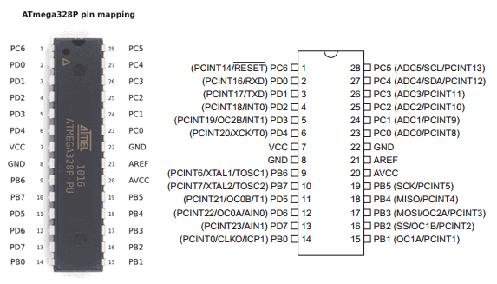**Parameter

Value

Flash (kBytes):

32 kBytes

Pin Count:

32

Max. Operating Freq. (MHz):

20 MHz

CPU:

8-bit AVR

# of Touch Channels:

16

Hardware QTouch Acquisition:

No

Max I/O Pins:

23

Ext Interrupts:

24

USB Speed:

No

USB Interface:

No

**REFERENCES**

"ATmega328P". Retrieved 2016-07-14. ^ Jump up to: a b c d e f g h "Atmel 8-bit AVR Microcontrollers ATmega328/P Datasheet Complete" (PDF). Retrieved 2016-07-14. Jump up ^ "megaAVR Microcontrollers". Atmel. Retrieved 2016-07-14. Jump up ^ "Atmel 8-bit AVR Microcontrollers ATmega328/P Datasheet Summary" (PDF). June 2016. Retrieved 2016-07-14.

**Stepper motor**

A **stepper motor** or **step motor** or **stepping motor** is a [brushless DC electric motor](https://en.wikipedia.org/wiki/Brushless_DC_electric_motor) that divides a full rotation into a number of equal steps. The motor's position can then be commanded to move and hold at one of these steps without any feedback sensor (an [open-loop controller](https://en.wikipedia.org/wiki/Open-loop_controller)), as long as the motor is carefully sized to the application in respect to torque and speed.

## Fundamentals of operation[[edit](https://en.wikipedia.org/w/index.php?title=Stepper_motor&action=edit&section=1" \o "Edit section: Fundamentals of operation)]

[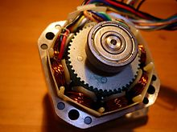](https://en.wikipedia.org/wiki/File:Stepper_motor.jpg)

A stepper motor

[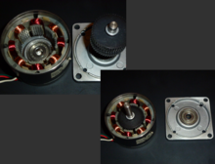](https://en.wikipedia.org/wiki/File:Stepper_BipolarHybrid.png)

A bipolar hybrid stepper motor

DC brushed motors rotate continuously when DC voltage is applied to their terminals. The stepper motor is known by its property to convert a train of input pulses (typically square wave pulses) into a precisely defined increment in the shaft position. Each pulse moves the shaft through a fixed angle.

Stepper motors effectively have multiple "toothed" electromagnets arranged around a central gear-shaped piece of iron. The electromagnets are energized by an external [driver circuit](https://en.wikipedia.org/wiki/Driver_circuit) or a [micro controller](https://en.wikipedia.org/wiki/Micro_controller). To make the motor shaft turn, first, one electromagnet is given power, which magnetically attracts the gear's teeth. When the gear's teeth are aligned to the first electromagnet, they are slightly offset from the next electromagnet. This means that when the next electromagnet is turned on and the first is turned off, the gear rotates slightly to align with the next one. From there the process is repeated. Each of those rotations is called a "step", with an integer number of steps making a full rotation. In that way, the motor can be turned by a precise angle.

**Global Positioning System**

### The Global Positioning System (GPS), also known as Navstar GPS[[1]](https://en.wikipedia.org/wiki/Global_Positioning_System#cite_note-1)[[2]](https://en.wikipedia.org/wiki/Global_Positioning_System#cite_note-2)[[3]](https://en.wikipedia.org/wiki/Global_Positioning_System#cite_note-3) or simply Navstar,[[4]](https://en.wikipedia.org/wiki/Global_Positioning_System#cite_note-4) is a [global navigation satellite system](https://en.wikipedia.org/wiki/Satellite_navigation) (GNSS) that provides [geolocation](https://en.wikipedia.org/wiki/Geolocation" \o "Geolocation) and time information to a [GPS receiver](https://en.wikipedia.org/wiki/GPS_receiver) in all weather conditions, anywhere on or near the Earth where there is an unobstructed line of sight to four or more GPS satellites.[[5]](https://en.wikipedia.org/wiki/Global_Positioning_System#cite_note-5) The GPS system operates independently of any telephonic or internet reception, though these technologies can enhance the usefulness of the GPS positioning information. The GPS system provides critical positioning capabilities to military, civil, and commercial users around the world. The United States government created the system, maintains it, and makes it freely accessible to anyone with a GPS receiver. However, the US government can selectively deny access to the system, as happened to the Predecessors[[edit](https://en.wikipedia.org/w/index.php?title=Global_Positioning_System&action=edit&section=2" \o "Edit section: Predecessors)]

The [Soviet Union](https://en.wikipedia.org/wiki/Soviet_Union) launched the first man-made satellite, [Sputnik 1](https://en.wikipedia.org/wiki/Sputnik_1), in 1957. Two American physicists, [William Guier](https://en.wikipedia.org/w/index.php?title=William_Guier&action=edit&redlink=1) and [George Weiffenbach](https://en.wikipedia.org/w/index.php?title=George_Weiffenbach&action=edit&redlink=1), at Johns Hopkins's [Applied Physics Laboratory](https://en.wikipedia.org/wiki/Applied_Physics_Laboratory) (APL), decided to monitor Sputnik's radio transmissions.[[14]](https://en.wikipedia.org/wiki/Global_Positioning_System#cite_note-guier-weiffenbach-14) Within hours they realized that, because of the [Doppler effect](https://en.wikipedia.org/wiki/Doppler_effect), they could pinpoint where the satellite was along its orbit. The Director of the APL gave them access to their [UNIVAC](https://en.wikipedia.org/wiki/UNIVAC_I) to do the heavy calculations required.

[](https://en.wikipedia.org/wiki/File:NAVSTAR_GPS_logo_shield-official.jpg)The next spring, Frank McClure, the deputy director of the APL, asked Guier and Weiffenbach to investigate the inverse problem — pinpointing the user's location, given that of the satellite. (At the time, the Navy was developing the submarine-launched [Polaris](https://en.wikipedia.org/wiki/UGM-27_Polaris) missile, which required them to know the submarine's location.) This led them and APL to develop the [TRANSIT](https://en.wikipedia.org/wiki/Transit_(satellite)) system.[[15]](https://en.wikipedia.org/wiki/Global_Positioning_System#cite_note-15) In 1959, ARPA (renamed [DARPA](https://en.wikipedia.org/wiki/DARPA) in 1972) also played a role in TRANSIT.[[16]](https://en.wikipedia.org/wiki/Global_Positioning_System#cite_note-16)[[17]](https://en.wikipedia.org/wiki/Global_Positioning_System#cite_note-Alexandrow-17)[[18]](https://en.wikipedia.org/wiki/Global_Positioning_System#cite_note-gap-18)

Official logo for NAVSTAR GPS

[](https://en.wikipedia.org/wiki/File:50th_Space_Wing.png)Emblem of the [50th Space Wing](https://en.wikipedia.org/wiki/50th_Space_Wing)

The first satellite navigation system, TRANSIT, used by the [United States Navy](https://en.wikipedia.org/wiki/United_States_Navy), was first successfully tested in 1960.[[19]](https://en.wikipedia.org/wiki/Global_Positioning_System#cite_note-19) It used a [constellation](https://en.wikipedia.org/wiki/Satellite_constellation) of five satellites and could provide a navigational fix approximately once per hour.

In 1967, the U.S. Navy developed the [Timation](https://en.wikipedia.org/wiki/Timation" \o "Timation) satellite that proved the ability to place accurate clocks in space, a technology required by GPS.

Indian military in 1999 during the [Kargil War](https://en.wikipedia.org/wiki/Kargil_War" \o "Kargil War).[[6]](https://en.wikipedia.org/wiki/Global_Positioning_System" \l "cite_note-6)

**Augmented Reality vs. Virtual Reality**

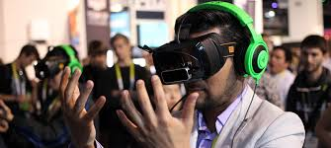Technology is improving at a rapid pace, as many things are possible today that were not possible 10 years ago even if we tried our best to make it happen. Today, some of the impossible things are rising to the occasion in the form of Augmented Reality and Virtual Reality. But what are they exactly? Let's find out.

What is Augmented Reality

Augmented reality is the blending of virtual reality and real life, as developers can create images within applications that blend in with contents in the real world. With AR, users are able to interact with virtual contents in the real world, and are able to distinguish between the two.

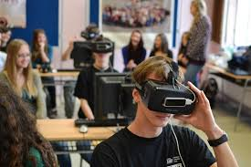What is Virtual Reality

Virtual reality is all about the creation of a virtual world that users can interact with. This virtual world should be designed in such a way that users would find it difficult to tell the difference from what is real and what is not. Furthermore, VR is usually achieved by the wearing of a VR helmet or goggles similar to the Oculus Rift.

Difference and similarities

Both virtual reality and augmented reality are similar in the goal of immersing the user, though both systems to this in different ways. With AR, users continue to be in touch with the real world while interacting with virtual objects around them. With VR, the user is isolated from the real world while immersed in a world that is completely fabricated.

**AR and Smartphones**

**PC MAKER** Asus is taking another stab at the smartphone market with the Zenfone AR, a high-end handset that supports both Google Tango and Daydream VR.

**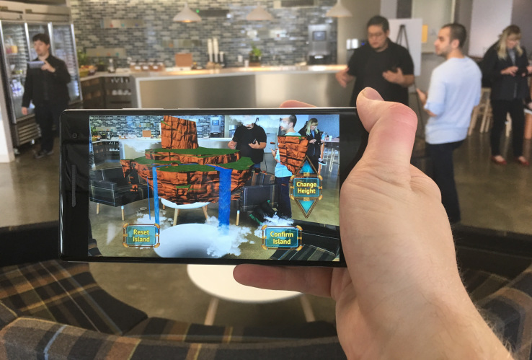**The Asus Zenfone AR, launched at CES on Wednesday, is the second Google Tango smartphone after the [**Lenovo Phab 2 Pro**](http://www.theinquirer.net/inquirer/news/2461125/lenovos-phab2-pro-is-the-first-tango-enabled-augmented-reality-smartphone). To enable its augmented reality smarts, the handset packs a TriCam system consisting of three rear cameras - a motion tracking, depth sensing, and high-resolution 23MP camera - that enable the phone to a create a 3D model of its surroundings and track its motion.

Asus has loaded some of its own AR experiences onto the phone, too. It's partnered with denim shop Gap to develop Dressing Room, an AR experience that let"s you virtually try on outfits, and with BMW on i Visualiser, an app that allows users to configure, customise, and walk around the car maker's i3 and i8 cars in a digital environment.

Asus also outed the Zenfone 3 Zoom at CES, a smartphone which packs a pair of rear-mounted cameras, similar to the [**Huawei P9**](http://www.theinquirer.net/inquirer/review/2454179/huawei-p9-review) and iPhone 7 Plus. There's a get a 12MP 'SuperPixel'  sensor with a wide f/1.7 aperture lens, and a secondary 12MP sensor.

There's also a 13MP camera on the front, 5,000mAh battery, 5.5in Full HD screen and a Qualcomm Snapdragon 625 processor. µ

**AR and GPS**

**Augmented reality** (**AR)** is a live direct or indirect view of a physical, real-world environment whose elements are *augmented* (or supplemented) by computer-generated sensory input such as sound, video, graphics or [GPS](https://en.wikipedia.org/wiki/GPS) data. It is related to a more general concept called [mediated reality](https://en.wikipedia.org/wiki/Mediated_reality), in which a view of reality is modified (possibly even diminished rather than augmented) by a computer. As a result, the technology functions by enhancing one’s current perception of reality.[[1]](https://en.wikipedia.org/wiki/Augmented_reality#cite_note-1) By contrast, [virtual reality](https://en.wikipedia.org/wiki/Virtual_reality) replaces the real world with a simulated one.[[2]](https://en.wikipedia.org/wiki/Augmented_reality#cite_note-2)[[3]](https://en.wikipedia.org/wiki/Augmented_reality#cite_note-3) Augmentation is

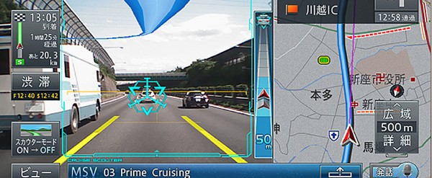

conventionally in [real time](https://en.wikipedia.org/wiki/Real-time_computing) and in semantic context with environmental elements, such as sports scores on TV during a match. With the help of advanced AR technology (e.g. adding [computer vision](https://en.wikipedia.org/wiki/Computer_vision) and [object recognition](https://en.wikipedia.org/wiki/Object_recognition)) the information about the surrounding real world of the user becomes [interactive](https://en.wikipedia.org/wiki/Interactive) and digitally manipulable. Information about the environment and its objects is overlaid on the real world. This information can be virtual[[4]](https://en.wikipedia.org/wiki/Augmented_reality#cite_note-4)[[5]](https://en.wikipedia.org/wiki/Augmented_reality#cite_note-5)[[6]](https://en.wikipedia.org/wiki/Augmented_reality#cite_note-6)[[7]](https://en.wikipedia.org/wiki/Augmented_reality#cite_note-Azuma_survey-7)[[8]](https://en.wikipedia.org/wiki/Augmented_reality#cite_note-8) or real, e.g. seeing other real sensed or measured information such as electromagnetic radio waves overlaid in exact alignment with where they actually are in space.[[9]](https://en.wikipedia.org/wiki/Augmented_reality#cite_note-9)[[10]](https://en.wikipedia.org/wiki/Augmented_reality#cite_note-10) Augmented reality brings out the components of the digital world into a person's perceived real world. One example is an AR Helmet for construction workers which displays information about the construction sites. The first functional AR systems that provided immersive mixed reality experiences for users were invented in the early 1990s, starting with the [Virtual Fixtures](https://en.wikipedia.org/wiki/Virtual_Fixtures) system developed at the U.S. Air Force's Armstrong Labs in 1992

##### Eyeglasses

AR displays can be rendered on devices resembling eyeglasses. Versions include eyewear that employ cameras to intercept the real world view and re-display its augmented view through the eye pieces[[28]](https://en.wikipedia.org/wiki/Augmented_reality#cite_note-28) and devices in which the AR imagery is projected through or reflected off the surfaces of the eyewear lens pieces